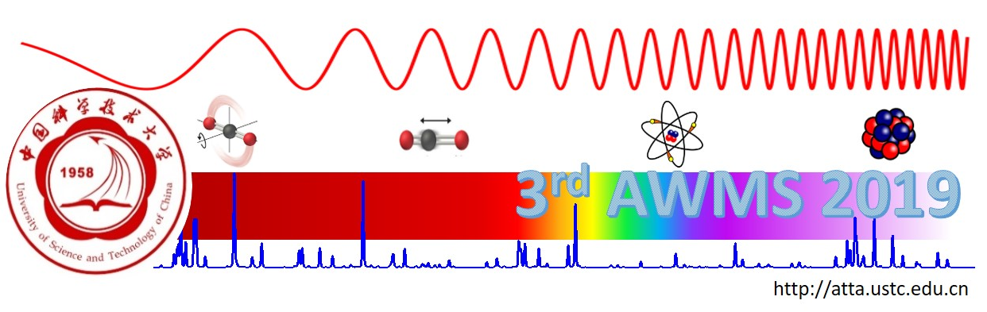

**The 3rd Asian Workshop on Molecular Spectroscopy  
  
第三届亚洲分子光谱研讨会  
  
（AWMS 2019）**

University of Science and Technology of China, Hefei

中国科学技术大学,合肥

March 6th-9th, 2019

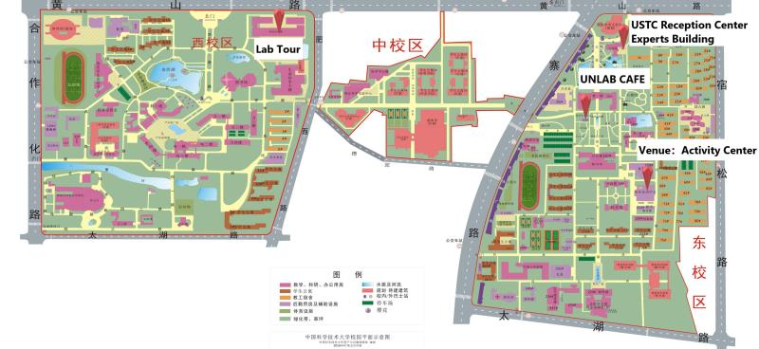

**Welcome to the 3rd Asian Workshop on Molecular Spectroscopy**

**March 6-9, 2019**

**University of Science and Technology of China, Hefei**

*On behalf of the Excutive Committee, I extend a heartfelt welcome to all the attendees of the 3rd Asian Workshop on Molecular Spectroscopy (AWMS 2019), and welcome you to the University of Science and Technology of China.*

*The workshop presents research in fundamental molecular spectroscopy and a wide variety of related fields and applications. The continued vitality and significance spectroscopy is annually re-affirmed by the number of talks, their variety, and the fact that many are given by students. These presentations are the heart of the meeting and are documented by this Abstract Book. Equally important is the information flowing from informal exchanges and discussions. It is our sincere hope that you will find this workshop informative and enjoyable both scientifically and personally. If we can help to enhance your experience, please do not hestitate to ask the worshop staff or the Excutibr Committee.*

*Shui-Ming Hu*

*Scheduale of Oral Presentations*

March 7………………….17

March 8………………….14

March 9…………………..9

*Specical Sessions:*

March 8, 16:30 Memorial Session dedicated to J. Hougen and L.-H. Xu

March 8, 18:30 Banquet

March 9, 14:00 Lab tour

**Committees**

International Advisory Committee

T. Amano, Jet Propulsion Laboratory, California Institute of Technology

M. Baba, Kyoto University

J. T. Hougen, National Institute of Science and Technology

Y. C. Hsu, Department of Physics, Taiwan National Central University

S.-M. Hu, University of Science and Technology of China

C. H. Kwon, Kangwon National University

Y. P. Lee, National Chiao Tung University

A. J. Merer, Institute of Atomic and Molecular Sciences, Academia Sinica,

& University of British Columbia

L.-H. Xu, University of New Brunswick

Local Organizing Committee

S.-M. Hu, University of Science and Technology of China, smhu@ustc.edu.cn

R.-F. Kan, Anhui Institute of optics and Fine mechanism, kanruifeng@aiofm.ac.cn

A.-W. Liu, University of Science and Technology of China, awliu@ustc.edu.cn

X.-A. Wang, University of Science and Technology of China, xawang@ustc.edu.cn

D.-F. Zhao, University of Science and Technology of China, dzhao@ustc.edu.cn

W.-X. Zhao, Anhui Institute of optics and Fine mechanism, wxzhao@aiofm.ac.cn

X.-G. Zhou, University of Science and Technology of China, xzhou@ustc.edu.cn

Sponsors

We are pleased to acknowledge the many organizations that support the 3rd workshop. Principal fundings come from the National National Science Foundation of China. We also acknowledge contributions from The University of Science and Technology of China in hosting the workshop.

Our Corporate Sponsors are **Edwards, Chinese Journal of Chemical Physics, Isoflex, and Apply Vacuum**. Please see the back of this book for their advertisements.



**Day 1, March 7th**

***Session A:***

*A-1.* High-resolution mid-infrared laser spectroscopy of small Criegee intermediates

………………………………………………..*Pei-Ling Luo, Yasuki Endo, and Yuan-Pern Lee*

*A-2.* High resolution laser spectroscopy of astrophysically relevant small molecules

…………………………………………………………………………………*Dongfeng Zhao*

*A-3.* Measurement of OH Radicals Based on Concentration Modulation Absorption Spectroscopy

………………………*Lun hua Deng, Bao Li, Jia li Qian, Li Wang, Bo Fang, Wei xiong Zhao*

*A-4.* HCl Formation in the Reaction of Cl Atom with trans-2-Butene Probed with Step-scan Time-resolved Fourier-transform IR Emission Spectroscopy

……….………………………………….*Yu-Hsuan Tsao, Yu-Yung Wang, and Yuan-Pern Lee*

***Session B:***

*B-1.* High-resolution spectroscopy of 9-methylanthracene

…….……………..*.Masaaki Baba, Ayumi Kanaoka, Masatoshi Misono, and Jon T. Hougen*

*B-2.* Rotational and theoretical characterization of sulfur centered non-covalent interactions

…..………………………………………………………………………………….*.Gang Feng*

*B-3.* The preferred conformers of the tetrafluoro-1,3-dithietane- isopropylamine complex by rotational spectroscopy

………………………………………….………………*Yan Jin, Tao Lu, Qian Gou, Gang Feng*

*B-4.* Study on the Stark effect to conversion of nuclear spin isomers of CH3OH

…………...………………..*Li-Sha Ma, Liang Guo, Pavel L. Chapovsky, and Zhen-Dong Sun*

***Session C:***

*C-1.* Highly Sensitive and Broadband Frequency Comb Spectroscopy Using a High Finesse Cavity

……………..*Akiko Nishiyama, Grzegorz Kowzan, Dominik Charczun*, *Przemysław Staniszewski,   
Agata Cygan, Ryszard S. Trawiński, Daniel Lisak, Piotr Masłowski*

*C-2.* Comb-assisted Pound-Dreve-Hall-locked cavity ring-down spectrometer

……………………………………………..*Ruimin Guo, Ke Cao, Hewei Dong, Wenchao Cui*

*C-3.* Frequency control of a single mode Ti:Sapphire laser with reference to an optical frequency comb

….……………..*Masatoshi Misono, Sho Yamasaki, Akiko Nishiyama, and Masaaki Baba*

*C-4.* Cavity-enhanced saturation spectroscopy of molecules with sub-kHz accuracy

……………………………………………...*T.-P. Hua, J. Wang, Y.R. Sun, A.-W. Liu, S.-M. Hu*

*C-5.* High-resolution Gigahertz and Terahertz Spectroscopy of the isotopically chiral molecule trans-2,3-dideutero-oxirane (c-CHD-CHDO)

………….……………………*Z. Chen, S. Albert, K. Keppler, M. Quack, V. Schurig, O. Trapp*

***Session D:***

*D-1.* Rotational Pursuits on Internal Dynamics of Water in Molecular Complexes

…………..*Juan Wang, Yan Jin, Junhua Chen, Gang Feng, Lorenzo Spada, Walther Caminati,   
Jens-U. Grabow, Cristina Puzzarini, Vincenzo Barone, Qian Gou*

*D-2.* *Ab initio* quantum scattering calculations of beyond-Voigt line-shape parameters for the H2-He system for the HITRAN database

……………………………………………*P. Wcisło, F. Thibault, N. Stolarczyk, H. Jóźwiak,   
M. Słowiński, M. Konefał, S. Kassi, A. Campargue, Y. Tan, J. Wang,*

*A.-W. Liu, S.-M. Hu, K. Patkowski, R. Ciuryło, D. Lisak, R.V. Kochanov, I.E. Gordon*

*D-3.* Mid-infrared quantum cascade laser spectroscopy of the Ar-NO complex: fine and hyperfine structure

……………………………………………………*Zhuang Liu, Wei Luo, and Chuanxi Duan\**

*D-4.* Dual Excitation-Emission Propagation (DEEP) vs. Coaxial Orientation Beam-Resonator Arragenment (COBRA) FTMW Spectrometers: Rotational Studies of (chiral) Molecules/Complexes in Jets (& Flames)

……………………………………………………………………………*Jens-Uwe Grabow*

**Day 2, March 8th**

***Session E:***

*E-1.* IR induced isomerization of invisible isomers (I5) spectroscopy: watching the invisible conformers of ortho-substituted phenols

…………*Cheol Joo Moon, Ahreum Min, Hak Seung Ryu, Woo Yeong Kim, Myong Yong Choi*

*E-2.* Infrared Spectra of BrC6H6 in Solid p-H2

…………………………….……………………………………..*Huei-Ru Tsai, Yuan-Pern Lee*

*E-3.* Spectroscopic Detection of Interstellar Sulfur Oxides

….…………………………………………………………………*Zhuang Wu, Xiaoqing Zeng*

*E-4.* Spectroscopic Studies of Luminescent Crystals Containing Trivalent Lanthanides

………………………………………………………..………………………Bor-Chen Chang

*E-5.* Quantum Vibration Perturbation Theory: A Way of Systematically Improving the Accuracy in Simulating Infrared Probe Spectra

……………………………*Yu Zhai, Yang Cong, Adam Grofe, Jiali Gao, and Hui Li*

***Session F:***

*F-1.* Vacuum Ultraviolet Free Electron Laser-Based Infrared Spectroscopy of Neutral Water Clusters

………………………………………………………..………………………………*Ling Jiang*

*F-2.* Rotational spectroscopy of the n-propylamine-water complex

………………………*Yang Zheng, Juncheng Lei, Lorenzo Spada, Gang Feng, Qian Gou*

*F-3.* Theoretical Investigations of the Optical Properties of Helicene-Iridium Complexes

…………………………………………*Qin Yang, Marco Fusè, Franco Egidi, Julien Bloino*

*F-4.* Molecular systems under external stimuli

………………………………………………………..……………………*Malgorzata Biczysko*

***Session G:***

*G-1.* Dissociation energy of molecular hydrogen at 10-9 accuracy

……*C. –F. Cheng, J. Hussels, E. J. Salumbides, H. L. Bethlem, S. –M. Hu, K. S. E. Eikema, W. Ubachs*

*G-2.* Electronic transitions of ScO in the UV region

………………………………………*A. S.-C. Cheung, Y.W. Ng, Na Wang and Wenli Zou*

*G-3*. A new 4Σ - a4Πi Electronic Transition of ScC in the near infra-red

……………………..……………………*Chiao-Wei Chen, Anthony J. Merer, Yen-Chu Hsu*

*G-4.* Infrared Spectroscopy of TiO in a supersonic jet expansion

*Daniel Witsch, Alexander A. Breier, Björn Waßmuth, Guido W. Fuchs, Thomas F. Giesen*

*G-5.* Line intensities of the radioactive isotopologues of the carbon monoxide molecule

…………………………………………………*Valerii I. Perevalov, Ekaterina V. Karlovets*

**Day 3, March 9th**

***Session H:***

*H-1.* Conversion dynamics of nuclear spin isomers of the CH3OH molecule in the gas phase

…...………………..*Zhen-Dong Sun, Li-Sha Ma, Yunhu Wu, and Pavel L. Chapovsky*

*H-2.* Spectral Characterization of Three-Electron Two-Center (3e-2c) Bonds of Gaseous CH3SH Clusters

………………………………….………………….*Min Xie, Asuka Fujii, Yuan-Pern Lee*

*H-3.* Sulfur hydrogen bonding: diethyl disulfide-H2O dimer in gas phase studied by microwave spectroscopy

………………………………….…………………*Xiaolong Li, Daniel A. Obenchain, Jiaqi Zhang, Sven Herbers, Qian Gou,Gang Feng, Jens-Uwe Grabow*

*H-4.* QVP Theory: Application to the Sum Frequency Generation

………………………………….………………………….……………*J-T. Yang, Hui Li*

*H-5.* Amyloid Fibrillation of Hen Egg White Lysozyme Acceerated by Succinimide

*……………………………….Wei Fan, Lei Xing, Mengna Li, Ning Chen, Xiaoguo Zhou*, Shilin Liu*

***Session I:***

*I-1.* Is the OH Stretching Vibrational Transition Moment of Simple Molecules Aligned Along the OH Bond?

………………………………….………………………….…………………..*Kaito Takahashi*

*I-2.* Near-IR spectroscopy of Radicals using cw-CRDS coupled to Laser photolysis

………………………………….………………………….………………….*.Christa Fittschen*

*I-3.* A proposal for laser directly cooling AgH & AgD radicals

………*Chuanliang Li, Yachao Li, Zhonghua Ji, Xuanbing Qiu, Yanting Zhao, Jinjun Liu*

*I-4.* The electronic excited state of C3Ar studied by hole burning spectroscopy and the ab initio calculation

……………………………………….………………………….…*Yen-Chu Hsu, Yi-Jen Wang*

***Poster Session:***

*P-1.*Rotational spectrum and non-covalent interaction of isopropylamine-water, an adduct of interstellar interest

……………*.Junhua Chen, Wanying Cheng, Meng Li, Lorenzo Spada, Gang Feng, Qian Gou*

*P-2.*DFB-QCLs in combination with a pulsed supersonic jet for high resolution infrared spectroscopy

*…………………………………………………………………………..Wei Luo，Zhuang Liu，Chuanxi Duan*

*P-3.*The aggregation of human islet amyloid polypeptide at lipid membrane is retarded significantly in low pH environment

….…………………………………………….…...*Jiahui Zhang, Junjun Tan, Shuji Ye*

*P-4.*Accurate measurement of helium-perturbed deuterium spectra for collisional studies and validation of the ab initio potential energy surfaces

*…………..A. Nishiyama, F. Thibault, M. Słowiński,M. Zaborowski, N. Stolarczyk, D.Charczun, A. Cygan, G. Kowzan, S. Wójtewicz, P. Masłowski, R. Ciuryło, D.Lisak, P. Wcisło*

*P-5.*S∙∙∙F Chalcogen Bond in the 2,2,4,4-Tetrafluoro-1,3-Dithiethane-Difluoromethane complex Revealed by Microwave Spectroscopic and Theoretical Study

*……….………………….…..Tao Lu, Yang Zheng, Zhining Xia,Qian Gou, Gang Feng*

*P-6.* Simulating Infrared Spectrum of *N*-MethylAcetamide Dimer by Quantum Vibration Perturbation Method

……………………………………………...... *You Li, Yu Zhai, Hui Li*

*P-7.*The inter- and intra-molecular potential energy surface and predicted infrared spectra for H2O-N2 dimer

………………………………….*Lu Wang, Xiao-Long Zhang, and Hui Li*

*P-8.*Influence of alkyl side-chain structure on charge transfer rate

*………………………………………………………..Chuanzhao Li, Yi Luo, Shuji Ye*

*P-9.*A systematic search for the best functionals to describe disulfide bond

…………………………………...…………………………..*.Hexu Ye , Malgorzata Biczysko*

*P-10.*Simulation of fully anharmonic IR spectra for flexible peptides

….………………………………..*.Ruiqin Xu, Malgorzata Biczysko, Bin Yan, Sjors Bakels*, *Robbert C. Ouwersloot, Dennis W. P. M. Löwik and Anouk M. Rijs*

*P-11.* Two new electronic transitions [21.2]0+ – *X*0+ and [22.2]0+ – *X*0+ of tungsten oxide (WO)

……………………………………………….*Jicai Zhang, Dongmei Zhao, Xinwen Ma, Jie Yang*

*P-12.*Vibronic spectra of jet-cooled 2-cyanoindole and its water clusters their and computational calculations

*……*…*Hak Seung Ryu, Cheol Joo Moon, Ahreum Min, Woo Yeong Kim, Myong Yong Choi*

*P-13* Photodissociation dynamics of the N2O+ cation via B2Π state

....................*Zhengfang Zhou, Hao Liang, Shaowen Feng, Yang Chen, Dongfeng Zhao*

*P*-14 Spectroscopic Detection of Elusive Oxyphosphinidene

…………………………………………………………………...*Xianxu Chu , Xiaoqing Zeng*

*P-15* Structure and Excited-state Dynamics of Corannulene

*…………………………………….……………..Ayumi Kanaoaka, Masaaki Baba, Masatoshi Misono, Masashi Tsuge, Pavithraa Sundararajan, and Yuan-Pern Lee*

*P-16*Theoretical investigations of rate coefficients of the H + H2O2 two-channel reaction on a full-dimensional potential energy surface

*……….…………………………………..Xiaoxiao Lu, Xing-an Wang, Bina Fu, Donghui Zhang*

*P-17* Molecular Spectroscopy with kHz Accuracy in the Mid-Infrared

*………………………………………………Z.-T. Zhang, C.-F. Cheng, Y. R. Sun, A.-W. Liu, S.-M. Hu*

***Poster Session:***

*P-18* Cavity-Assisted Velocity-selected Optical Double-resonance Spectroscopy (CAVODS) of molecules with continuous-wave lasers

*………………C.-L. Hu, A.-W. Liu, C.-F. Cheng, T.-P. Hua, Y. R. Sun, Y. Tan, J. Wang, S.-M. Hu*

*P-19* Lamb-dip Measurement of the Overtone Transition of HD at 1.39 μm

*………………………………………..………T.-P. Hua, J. Wang, Y. R. Sun, A.-W. Liu, S.-M. Hu*

*P-20*Measurement of Absolute 12C16O2 Transition Frequencies in (30013)-(00001) Band

.........................................................................*H. Wu, C.-L. Hu, Y. R. Sun, A.-W. Liu, S.-M. Hu*

*P-21*Near infrared-to-near ultraviolet triplet-triplet annihilation upconversion by strong spin-forbidden transition

*……………………………………………Min zheng, Yaxiong Wei, Xiaoguo Zhou, Shilin Liu*

*P-22*Double-edged effect of Al(III) ions on amyloid fibrillation of hen egg white lysozyme revealed by Raman spectroscopy

………..………..*Lei Xing , Ning Chen , Wei Fan, Mengna Li , Xiaoguo Zhou, Shilin Liu*

*P-23*Pyrolysis of Methylal Revealed by Imaging Photoelectron Photoion Coincidence Spectroscopy

……………….*Tongpo Yu, Patrick Hemberger, Xiaoguo Zhou , Shilin Liu，Andras Bodi*

*P-24* The A2Пu - X2Пg electronic transition of Br2+

…………………………….*Hao Liang, Zhenfang Zhou, Yang Chen*, and Dongfeng Zhao*

*P-25* A Cryogenic Cylindrical Ion Trap Velocity Map Imaging Spectrometer

……………………………………………..*Zefeng Hua, Yang Chen****＊****, and Dongfeng Zhao*

*P-26*Velocity map imaging study on the singlet and triplet dissociation pathway of OCS near 230 nm

…………………………………….*.XiangKunWu，ZhiGao，XiaoGuoZhou*，ShiLinLiu\**

*P-27* High precision rotational constants of 12C16O determined by ro-vibrational transitions

..…………………………*Jin Wang, Changle Hu, Yu Robert Sun, Anwen Liu,*, Shuiming Hu*

*P-28.* Hydrogen generation and CO oxidation by catalysts of platinum-based small cluster Pt3Si

*…………………………...Wen-Li Xie, Hui Ma, Run-Qin Liu, Yi-Fen Wu, and Zhen-Dong Sun*

*P-29.* A bonding model for noble gas hydrides and noble gas-noble metal halides

…………*Yue Su, Lei Fu, Junjie Song, Gong Zhang, Kongshuang Tang, and Guiqiu Zhang*

*P-30.*Visible Emission Spectroscopy of Benzyl-type Radicals Generated from 4-Chloro-*m*-Xylene……………………………………………………………………. *Sang Kuk Lee*

*P-31*CO2-broadening and shift coefficients of sulfur dioxide near 4 µm

……………………*.Yurii G. Borkov, Oleg M. Lyulin, Tatyana M. Petrova, Alexander M. Solodov, Alexander A. Solodov, Vladimir M. Deichuli, Valerii I. Perevalov*

*P-32* Comb-assisted Pound-Drever-Hall locked cavity ring-down spectrometer

…………………………………………….*.Ruimin Guo*, Ke Cao, Hewei Dong, Wenchao Cui*

*P-33.*QCL-based Ammonia Slip Sensor in Thermal Power Plant DeNOx Process

………………………………………………………...*Peng Kang, Ting-Jung Lin, Yin Wang*

***A-1***

**High-resolution mid-infrared laser spectroscopy of small Criegee intermediates**

Pei-Ling Luo1, Yasuki Endo2, and Yuan-Pern Lee1,2

*1Institute of Atomic and Molecular Sciences, Academia Sinica, Taipei 10617, Taiwan*

*2Department of Applied Chemistry and Institute of Molecular Science, National Chiao Tung University, Hsinchu 30010, Taiwan*

The Criegee intermediates, CR1R2OO, are carbonyl oxides produced in the ozonolysis of unsaturated hydrocarbons and play significant roles in atmospheric chemistry. Recently, we have achieved the high-resolution infrared laser spectroscopy of small Criegee intermediates with a quantum-cascade laser (QCL) in region 880−932 cm−1. This work marks the first time that a completely resolved vibration-rotational band of CH2OO extending over 50 cm−1 has been recorded, so enabling a perturbation in the rotational states of the OO-stretching mode to be identified [1]. In addition, the high resolution spectrum with temporal profiles provides also clear evidence for several resolved lines of hot bands. More importantly, we identified some spectral lines solely due to *syn*-CH3CHOO with no interference from *anti*-CH3CHOO; this is the first conformer-specific detection for larger Criegee intermediates. Probing these lines, we determined the rate coefficient for the self-reaction of *syn-*CH3CHOO to be *k*self = (1.6)×10−10 cm3 molecule−1 s−1, about twice that of CH2OO [2].

References:

[1] P.-L. Luo, Y. Endo, and Y.-P. Lee, *Phys. Chem. Chem. Phys.*, **20**, 25806 (2018).

[2] P.-L. Luo, Y. Endo, and Y.-P. Lee, *J. Phys. Chem. Lett.* **9**, 4391 (2018).

***A-2***

**High resolution laser spectroscopy of astrophysically relevant small molecules**

Dongfeng Zhao

*CAS Center for Excellence in Quantum Information and Quantum Physics, Hefei National Laboratory for Physical Sciences at the Microscale, and Department of Chemical physics, University of Science and Technology of China, Hefei, Anhui, 230026, P.R. China.*

About 200 molecules have been identified in the inter- and circumstellar medium, the highly dilute regions in between and around stars. The observation of these molecules provides excellent diagnostics of the physical conditions and chemical processes in the environments where they exist. In recent years, we have performed laboratory spectroscopic studies on astrophysically relevant small molecules, motivated to provide direct laboratory data needed to support and guide on-going and future observational missions in astrochemistry. Transient species of astrophysical interest are produced in a supersonically expanding plasma jet by pulsed gas discharge. High resolution spectra for species such as C3 and Si2 are studied using CRDS and LIF. The resulting laboratory data are supportive towards nowdays astronomy, and it also stands on its own for a comprehensive understanding of the intrinsic molecular properties.

Very recently, we have also developed a cryogenic cylindrical ion trap velocity map imaging spectrometer (CIT-VMI) for photodissociation spectroscopy and dynamics of gaseous molecular ions and ionic complexes. A cylindrical ion trap (CIT), which can be cryogenically cooled down to ~7 K, serves as a robust cold ion source with a well-confined velocity spread. Proof of principle experiments on applications of this new instrument will also be presented.

***A-3***

**Measurement of OH Radicals Based on Concentration Modulation Absorption Spectroscopy**

Lun hua Deng1, Bao Li1, Jia li Qian1, Li Wang1, Bo Fang2, Wei xiong Zhao2

*1 State Key Laboratory of Precision Spectroscopy, East China Normal University,3663 Zhongshan Road (N.), Shanghai, 200062，China*

*2 Laboratory of Atmospheric Physico-Chemistry, Anhui Institute of Optics and Fine Mechanics, Chinese Academy of Sciences, Hefei, 230031, Anhui, China*

The reactions of OH radicals with other radicals play an important role in atmospheric chemistry. Therefore, their reactions have been extensively studied in laboratory, field measurements [1], and simulations. An absorption cell containing stable concentration of OH radicals is very useful in many applications.

In this study, we report a stable concentration of OH radicals produced by discharging water vapor. The absorption spectra of OH are measured using concentration modulation absorption technique and the spectral intensities of water vapor are well reduced. Water vapor discharge is known to be an effective source of OH radicals [2]. By discharging, OH radicals may also be produced in their excited vibrational levels, similar as they exist in the upper atmosphere. This OH cell with stable concentration can be used as a reference gas in the application of radical molecular spectroscopy. The developed system can be used to produce other radicals with stable concentration.

References:

[1] Weixiong Zhao, Bo Fang, Xiaoxiao Lin, Yanbo Gai, Weijun Zhang, Wenge Chen, Zhiyou Chen, Haifeng Zhang, and Weidong Chen, *Analytical Chemistry,* 90, 3958 (2018).

[2] Weixiong Zhao, Lunhua Deng, Xuezhe Xu, Weidong Chen, Xiaoming Gao, Wei Huang, and Weijun Zhang Proceedings of Imaging and Applied Optics 2014, Seattle, WA, U.S.A., July 13−17, 2014; The Optical Society, 2014: paper JTu4A.31.

***A-4***

**HCl Formation in the Reaction of Cl Atom with trans-2-Butene Probed with Step-scan Time-resolved Fourier-transform IR Emission Spectroscopy**

Yu-Hsuan Tsao1, Yu-Yung Wang1, and Yuan-Pern Lee1,2

*1Department of Applied Chemistry and Institute of Molecular Science, National Chiao Tung University,1001, Ta-Hsueh Road, Hsinchu 30010, Taiwan.*

*2Institute of Atomic and Molecular Sciences, Academia Sinica, Taipei 10617, Taiwan.*

Reactions between Cl atoms and unsaturated hydrocarbons play important roles in atmospheric chemistry. In such reactions, HCl is produced from either direct abstraction of an allylic H atom by Cl or addition-elimination, in which the Cl atom first adds to the C=C double bond to form a chloroalkyl radical, followed by abstraction of an H atom of the methyl moiety to produce HCl and an alkenyl radical. The relative contributions of these two channels depend on the pressure and temperature [1][2]. Recently, a roaming mechanism mediating the addition-elimination pathway of Cl + isobutene was suggested; it becomes significant at low collisional energies [3]. This roaming mechanism was further supported through observation of the enhanced rate for the formation of HCl, investigated with the step-scan FTIR emission spectroscopy, when sufficient Ar was added in the system to enhance the roaming [4]; Ar quenches efficiently the kinetic energy of Cl atom after photolysis to reduce the collision energy.

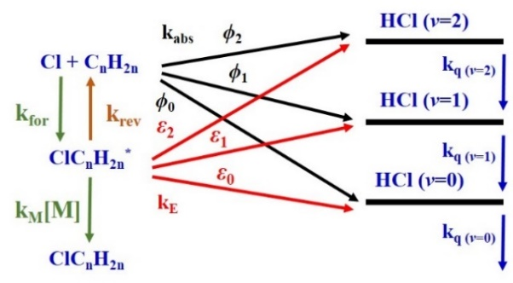This work is aimed at investigating HCl formation pathways in the reaction of Cl + *trans*-2-butene with a step-scan time-resolved FTIR spectrometer. The experiments were carried out at 298 K under pseudo first-order conditions. Ar buffer gas in varied proportion was added to the system so that the total pressure reached 0.47, 1, 2, or 3 Torr, respectively. IR emission of HCl in region 2350−3330 cm-1 was observed, and emission lines of HCl (*v*=1, *J* ≤ 11 and *v*=2, *J* ≤ 7) were assigned. We simulated the temporal profiles of HCl (*v*=1 or *v*=2) according to the proposed mechanism presented in Fig. 1. In the simulation, literature rate coefficient *k*abs = 4.6×10−11 , and *k*for = 2.7×10−10 cm3 molecule−1 s−1 were fixed, and *k*E, *k*rev, *k*q, *k*M, *ε*2/*ε*1, and *ϕ*2/*ϕ*1 were fitted with the temporal profiles. We found enhanced kE that are about 10 times greater than those in Cl + propene, similar to what was observed in Cl + isobutene. We also found that the ratio [HCl(*v*=2)]/ [HCl(*v*=1)] = (0.10±0.01) is about 1.9 times greater than that of Cl + propene.

Fig. 1 Mechanism of Cl + alkene

References:

[1] E. W. Kaiser, T. J. Wallington, *J. Phys. Chem.*, **100**, 9788-9793 (1996); [2] C. A. Taatjes, *Int. Rev. Phys. Chem.*, **18**, 419-458 (1999); [3] B. Jolland, R. V. Camp, Y. Shi, A. G. Suits, *J. Phys. Chem. A*, **117**, 7589-7594 (2013); [4] L. W. Chen, C. M. Hung, H. Matsui, Y. P. Lee, *Sci. Rep.*, **7**, 40105 (2017)

***B-1***

# High-resolution spectroscopy of 9-methylanthracene

Masaaki Baba1, Ayumi Kanaoka1, Masatoshi Misono2, and Jon T. Hougen3

*1Graduate School of Science, Kyoto University, Sakyo-ku, Kyoto 606-8502, Japan*

*2Faculty of Science, Fukuoka University, Jonan-ku, Fukuoka 814-0180, Japan*

*3Sensor Science Division, NIST, Gaithersburg, Maryland 20899-8441, United States*

Methyl (CH3) internal rotation is of great interest because the vibrational and rotational level energies are sensitive to each molecular structure. Toluene is one of the prototypical molecules of six-fold symmetry and the barrier to rotation (*V*6) is quite small in the S0 state. The potential energy is considered to be dominated by hyperconjugation by the results of high-resolution spectroscopy [1]. In order to investigate the contribution, we observed and analyzed the rotationally resolved spectrum of the S1 ← S0 0-0 band of an analogous molecule, 9-methylanthracene in a collimated supersonic jet using a single-mode ring Ti:S laser. The result is shown in Fig. 1.

 The vibrational energy levels of CH3 internal rotation were already investigated by supersonic-jet spectroscopy using a nanosecond pulsed dye laser [2]. It was shown that the *V*6 value was considerably large. We are now determining the rotational constants of 9-methylanthracene by high-precision and high-resolution spectroscopy utilizing the technique of optical frequency comb. Our final goal is to fully analyze the energy levels of all vibrational and rotational levels and find out the best Hamiltonian to completely reproduce them.

Fig. 1: Rotationally resolved high-resolution spectrum of S1 ← S0 0-0 band of

9-methylanthracene in a collimated supersonic jet.

References:

[1] M. Baba, et al., *J. Phys. Chem. A* **113**, 2366 (2009).

[2] D. R. Borst and D W. Pratt, *J. Chem. Phys.* **113**, 3658 (2000).

***B-2***

# Rotational and theoretical characterization of sulfur centered non-covalent interactions

Gang Feng

*School of Chemistry and Chemical Engineering, Chongqing University, Chongqing, China*

Hydrogen bonding involving sulfur plays a pivotal role in a range areas, and determines, for example, structures of proteins and their interactions in living systems and the initial steps of aerosol particle formation. Additionally, sulfur can act as electrophilic centers to form so-called chalcogen bond. Microwave spectroscopy in combination with quantum chemical calculations is a powerful approach to study these kinds of non-covalent interactions. Several molecular complexes, namely diethyl disulfide-H2O, 2,2,4,4-Tetrafluoro-1,3-dithiethane-H2O, 2,2,4,4-Tetrafluoro-1,3-dithiethane-ammonia and 2,2,4,4-Tetrafluoro-1,3-dithiethane - isopropamide will be discussed. In the spectra, splittings of rotational lines were observed, which are attributed to large amplitude tunneling motions involving the water moiety or 14N quadruple coupling. The spectroscopic results are interpreted using ab initio calculations, quantum theory of atoms in molecules, non-covalent interactions analysis and Symmetry-Adapted Perturbation theory (SAPT) analysis to shed light on the non-covalent interactions at play.

***B-3***

**The preferred conformers of the tetrafluoro-1,3-dithietane- isopropylamine complex by rotational spectroscopy**

Yan Jin1, Tao Lu1, Qian Gou1,2, Gang Feng1,2

*1 School of Chemistry and Chemical Engineering, Chongqing University, Daxuecheng South Rd. 55, 401331 Chongqing, China*

*2 Collaborative Innovation Center for Brain Science, Chongqing University, No. 174, Shazhengjie, Shapingba, Chongqing 400044, China*

Abstract: The complex of tetrafluoro-1,3-dithietane and isopropylamine have been studied by supersonic-jet Fourier transform microwave spectroscopy. The rotational spectra of *gauche* and *trans* conformers both have been observed. Experimental results and *ab initio* calculations support that the *gauche* conformer is more stable than the *trans* one. Non-covalent interaction (NCI), Quantum theory of atoms in molecules (QTAIM) and Symmetry-Adapted Perturbation theory (SAPT) analyses have been performed to reveal the stability of the *gauche* and *trans* conformers according to the intermolecular interactions.

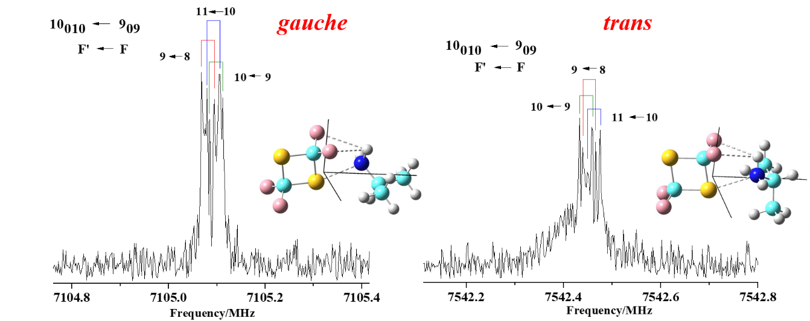

***B-4***

# Study on the Stark effect to conversion of nuclear spin isomers of CH3OH

Li-Sha Ma1, Liang Guo2, Pavel L. Chapovsky3, and Zhen-Dong Sun1,2*,

*1School of Physics, Shandong University, Jinan 250100, China*

*2School of Physics and Electrical Engineering, Kashgar University, Kashgar 844006, China*

*3Institute of Automation and Electrometry, Russian Academy of Sciences, Novosibirsk, 630090, Russian Federation*

*\**Email: [zdsun@sdu.edu.cn](mailto:xuhf@jlu.edu.cn)

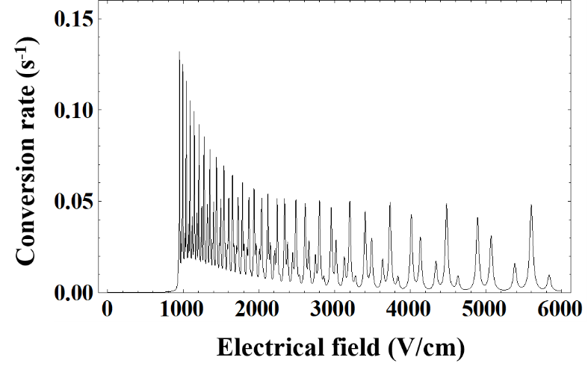Two nuclear spin isomers of ortho-CH3OH and para-CH3OH are formed in the CH3OH molecule, which correspond to the orentations of nuclear spins in hydrogen nuclei of the CH3-group are in parallel and in anti-parallel for one of them to the other two, and populate in energy levels of the states of *A* and *E* torsional symmetry, respectively. It was predicated that isomerizations of different species of spin isomers can be induced by funnels through the near-degenerate levels [1]. Accordingly, the ortho-para conversion rate has been given by the model of quantum relaxation [2]. For CH3OH in this study, we have examined this mixing theory by study the Stark effect to variations of the ortho-para conversion rates on the applied electric fields. For the ground-state *A*−*E* species level pair in quantum numbers of (υt *K*±, *J*) =(0 4-, 24) − (0 2, 25) located at energy about 667.490 cm-1 with an energy gap of 47 MHz, where υt is the torsional quantum number, we have found that the Stark effect causes the gap deductions of this pair of energy levels and the energy level-crossings at some magnetic sublevels. When the electric fields are larger than about 920 V/cm, as shown in the following figure, one can see that the nuclear spin conversion rates reach to maxima at the level-crossing electrical fields and change sharply with variations of the electrical fields near the energy level-crossings.

References:

[1] R. F Curl Jr, J. Kasper, and K. Pitzer, *J. Chem. Phys.* **46**, 3220 (1967).

[2] P. L. Chapovsky, *Phys. Rev. A* **43**, 3624 (1991).

**Acknowledgements**：This research was partially supported by NSFC (Nos. 91536105 and 11174186), Natural Science Foundation of Xinjiang Uigur Autonomous Region (No.2016D01A015), and the Tianshan Scholar Program.

***C-1***

# Highly Sensitive and Broadband Frequency Comb Spectroscopy Using a High Finesse Cavity

Akiko Nishiyama1,2,3, Grzegorz Kowzan1, Dominik Charczun1, Przemysław Staniszewski1, Agata Cygan1, Ryszard S. Trawiński1, Daniel Lisak1, Piotr Masłowski1

*1Institute of Physics, Faculty of Physics, Astronomy and Informatics, Nicolaus Copernicus University in Torun, ul. Grudziadzka 5, 87-100 Torun, Poland; 2Department of Engineering Science, Graduate School of Informatics, The University of Electro-Communications (UEC), 1-5-1 Chofugaoka, Chofu, Tokyo 182-8585, Japan; 3Japan Society for the Promotion of Science (JSPS)*

The direct frequency comb spectroscopies using a high finesse cavity, such as cavity enhanced absorption spectroscopy (CEAS) [1], cavity mode-width spectroscopy (CMWS), and cavity mode dispersion spectroscopy (CMDS) [2], realize highly sensitive measurements over the broadband frequency comb spectrum. In this study, we performed these three cavity-enhanced spectroscopies employing the comb-based Fourier-transform spectroscopy (FTS) [3] which realizes high-resolution beyond a limit of the resolution determined by optical path length of FT interferometer, and we demonstrated the measurement of the second overtone band (0-3) of CO in near infrared region.

Figure 1(a) shows the experimental setup for comb-based CEAS. A Er:fiber comb with the repetition rate of 250 MHz was used as a spectroscopic light source, and the output was coupled into a high-finesse cavity filled with CO-Ar mixture. The cavity with a finesses of 21000 and with free spectral range matched to the repetition rate of the comb was locked to the comb modes using two point Pound-Drever-Hall lock scheme [1]. Transmission spectrum of the cavity was observed with home-built high-resolution FTS system (Fig. 1(b)). Observed absorption line shapes are well fitted to speed-dependent Voigt profiles rather than Voigt profile, thus we can discuss speed-dependent collisional line shape effects in whole ro-vibrational band. The comb-based cavity spectroscopies are useful to verify collisional line-shapes parameters which is crucial for future spectral databases.

In the measurements of CMWS and CMDS, we used a different experimental setup to scan the comb modes around cavity resonances. We observed 20 kHz-width cavity modes with the resolution of 3 kHz and frequency accuracy of 20 Hz, and obtained absorption and dispersion spectra of 0-3 band of CO from observed cavity mode width and mode positions.

This work was supported by National Science Centre, Poland (No. UMO-2016/23/B/ST2/00730 ) and JSPS KAKENHI Grant Numbers 16J02345, 17K14435.

[1] A. Foltynowicz, et al., Physical Review Letters 107, 233002 (2011); [2] A. Cygan, et al., J. Chem. Phys. 144, 214202-1 (2016); [3] P. Masłowski, et al., Phys. Rev. A 93, 021802(R) (2016).

***C-2***

# Comb-assisted Pound-Dreve-Hall-locked cavity ring-down spectrometer

Ruimin Guo, Ke Cao, Hewei Dong, Wenchao Cui

*Division of Energy and Environmental Measurement, National Institute of Metrology, Beijing, China*

*Email: guorm@nim.ac.cn*

We report our cavity ring-down spectrometer built in National Institute of Metrology, China. The experimental setup includes cavity length stabilization loop, Pound-Drever-Hall (PDH) locking loop, frequency comb part and temperature stabilization loop.The 1-meter-long cavity is actively stabilized to a HeNe laser and the length variation is measured to be less than 3 nm in 3 hours [1]. The light for an infrared external cavity diode laser (ECDL) is divided into two beams. The p-polarized beam serves as the probe light, which is switched on-off by an acoustic-optic modulator (AOM) to measure the ring-down signal. The s-polarized light is phase-modulated by an electro-optic modulator (EOM) to produce the sidebands need for the PDH technique [2]. The probe laser is kept to be tightly locked to the high finesse (about 190000) cavity during the ring-down signal measurement. An optical frequency comb is used to automatically measure the probe frequency for all the frequency points, which provide a high precise frequency axis for the measured molecular spectra. Four thermal transducers are put along the cavity to monitor the temperature and the variation of the average temperature is less than 5 mK in 2 hours. The minimum detectable absorption coefficient and the noise-equivalent absorption coefficient are about 7.6×10-12cm-1 and 5.3×10-12cm-1Hz-1/2, respectively.

The CO2/N2 mixture with a CO2 concentration of 2472.5 ppm is prepared to measure the P32e (30012)(00001) 12C16O2 transition with a pressure range of 2-26 Torr. The measured data are analyzed using the Voigt profile (VP), the Galatry profile (GP), the Nelkin–Ghatak profile (NGP) and the speed-dependent VP (SDVP) with multispectrum fitting method. The line parameters such as line position and line intensity are botained

References:

[1] Joseph T. Hodges, Howard P. Laye et al., *Rev. Sci. Instrum*. **75**, 849 (2004)

[2] A. Cygan, D. Lisak et al., *Rev. Sci. Instrum*. **82**, 063107 (2011)

***C-3***

**Frequency control of a single mode Ti:Sapphire laser**

**with reference to an optical frequency comb**

Masatoshi Misono1, Sho Yamasaki1, Akiko Nishiyama2, and Masaaki Baba3

*1Faculty of Science, Fukuoka University, Jonan-ku, Fukuoka 814-0180, Japan*

*2University of Electro-Communications, Chofu, Tokyo 182-8585, Japan*

*3Graduate School of Science, Kyoto University, Sakyo-ku, Kyoto 606-8502, Japan*

We have been studied the dynamics of polyatomic molecules by high-resolution spectroscopy with a supersonic molecular beam or by Doppler-free two-photon absorption spectroscopy. We have already observed and analyzed high-resolution spectra of small aromatic hydrocarbons, such as benzene and naphthalene. And we proceed to larger polyaromatic hydrocarbons, such as 9-methylanthracene, 1,2-benzanthracene and perylene. In these spectroscopies, the determination of the frequency axis is a crucial issue [1]. In this study, we developed a frequency control system of a cw Ti:Sapphire laser with reference to an Er-doped fiber optical frequency comb (Er comb).

The precision frequency control system is shown in Fig. 1. A part of the output of a cw Ti:Sapphire laser is split, and its frequency is shifted by an Acousto-Optic Frequency Shifter (AOFS) in double pass configuration. Then the shifted light is overlapped with the output of an Er comb, and the beat signal, whose frequency is *f*beat, is observed by a photodiode (PD). The repetition rate *f*rep and the carrier-envelope offset frequency *f*CEO of the Er comb are locked to the output frequencies of signal generators locked to a GPS clock. Thus the frequency of a comb mode is *nf*rep + *f*CEO, where *n* is the mode number. The Ti:Sapphire laser frequency *f*laser and other frequencies have the following relation,

*f*laser + 2*f*AOM = (*nf*rep + *f*CEO) + *f*beat.

By locking *f*beat, the right hand side of the equation becomes constant. Therefore, when we scan *f*AOM, *f*laser is scanned in the opposite direction.

As a demonstration, we scanned *f*laser with reference to the Er comb, and measured the output power of a confocal cavity (Fig. 2). The top trace is *f*AOM generated by a computer, the middle trace is observed *f*beat, and the bottom trace is the cavity transmission power. In this case, since *f*AOM is scanned downward, *f*laser is scanned upward. The abscissa in Fig. 2 is determined by the method described above. We try to observe high-resolution spectra of polyaromatic hydrocarbons with this system.

[1] A. Nishiyama, A. Matsuba, and M. Misono, *Opt. Lett*. **39**, 4923 (2014).

***C-4***

**Cavity-Enhanced Saturation Spectroscopy of Molecules with sub-kHz accuracy**

T.-P. Hua, J. Wang, Y.R. Sun, A.-W. Liu, S.-M. Hu

*Hefei National Laboratory for Physical Sciences at Microscale, University of Science and Technology of China, Hefei, 230026 China*

Precise frequency measurements of molecular transitions play an essential role in widespread applications, such as frequency metrology, astronomy, and molecular spectroscopy. There are also increasing interests to use precise molecular transitions to test the quantum electrodynamics (QED) theory, to determine fundamental physical constant or to verify its stability, and to search parity-violating effects in chiral molecules. Moreover, reliable molecular frequencies are also candidates for optical clocks.

Saturated spectroscopy is frequently used to obtain sub-Doppler measurement of molecular transitions. Optical resonance cavities can be used to enhance the effective absorption path length, and the laser power inside the cavity as well to saturate very week ro-vibrational transitions of molecules. Three different cavity enhanced methods, CEAS, CRDS, NICE-OHMS, were compared by measuring the Lamp dip of a C2H2 line at 1.4um using a cavity with a finesse of 120,000. The center of the line was determined by different methods, each giving a sub-kHz statistical uncertainty. The sensitivity and precision of these methods were analyzed and compared. As demonstrated in this study, the NICE-OHMS method is the most sensitive one, but more investigation on the systematic uncertainty is necessary before its application in metrology studies toward a sub-kHz accuracy.

The position of the HD R(1) line at 1.39um detected by NICE-OHMS disagrees with that obtained from CRDS. The reason is yet unknown. Here we present a direct comparison of all these three methods using the same optical cavity to measure HD transitions at 1.39um[3,4]. In our experiments, we improved the measurement sensitivity by almost an order of magnitude, and found profile distortion in HD Lamp dips measured by three methods. The spectrum cannot be fitted with a Lorentzian profile, which should be the reason of the deviation between previously reported line centers.

References:

[1] L.-G. Tao, T.-P. Hua, Y. R. Sun, J. Wang, A.-W. Liu, and S.-M. Hu, “Frequency metrology of the acetylene lines near 789nm from lamb-dip measurements,” *J. Quant. Spectrosc. Radiat. Transf* **210**, 111 – 115 (2018).

[2] Hua, T. P., Sun, Y. R., Wang, J., Liu, A. W., & Hu, S. M. “Frequency metrology of molecules in the near-infrared by NICE-OHMS,” *Opt. Express* *27*(5), 6106 (2019).

[3] L.-G. Tao, A.-W. Liu, K. Pachucki, J. Komasa, Y. R. Sun, J. Wang, and S.-M. Hu, “Toward a determination of the proton-electron mass ratio from the lamb-dip measurement of HD,” Phys. Rev. Lett. **120**, 153001 (2018).

[4] F. M. J. Cozijn, P. Dupré, E. J. Salumbides, K. S. E. Eikema, and W. Ubachs, “Sub-doppler frequency metrology in HD for tests of fundamental physics,” Phys. Rev. Lett. **120**, 153002 (2018).

***C-5***

**High-resolution Gigahertz and Terahertz Spectroscopy of the isotopically chiral molecule trans-2,3-dideutero-oxirane (c-CHD-CHDO)**

Z. Chen1,2, S. Albert2, K. Keppler2, M. Quack2, V. Schurig3, O. Trapp4

*1College of Chemistry and Chemical Engineering, Lanzhou University,*

*Lanzhou 730000, China,*

*2Laboratorium für Physikalische Chemie, ETH Zürich, CH-8093 Zürich, Switzerland*

*3Institut für Organische Chemie, Eberhard-Karls-Universität,*

*D-72076 Tübingen, Germany*

*4Department Chemie, Ludwig-Maximilians-Universität, D-81377 München, Germany*

We report the observation and assignment of the rotational spectra of the isotopically chiral molecule, trans-2,3-dideutero-oxirane (c-CHD-CHDO) measured in the Gigahertz range of 62-110 GHz (∆ν/ν = 10−11) and in the Terahertz range, 25-80 cm-1 (Δῦ = 0.00052 cm−1). Normal oxirane (c-C2H4O) has been detected by astrophysical spectroscopy in space **[1]**.A small number of lines of trans-2,3-dideutero-oxirane had been previously analyzed in the microwave region **[2]** up to 70 GHz**.** We have recently **[3]** measured and successfully analyzed the rotational spectrum of monodeutero-oxirane between 65 and 119 GHz using our GHz spectrometer **[4],** and in the 0.75 to 2.5 THz range measured with our FTIR setup **[5]** at the Swiss Light Source. Here we discuss our study of the spectrum of trans-2,3-dideutero-oxirane using setups described in **[4,5]**. We were able to assign and analyze more than 2500 rotational transitions of the vibronic ground state of trans-2,3-dideutero-oxirane up to *J=*65. The molecule is also of interest in the context of molecular parity violation, similar to the related molecule fluoro-oxirane [**6**]. Our results are important in relation to isotopic chirality and parity violation [**7**], and to the possible astrophysical observation of this molecule.

**[1]** J. E. Dickens, et al.,  *ApJ*, **1997**, 489, 753 ;M. Ikeda, et al., *Astrophys. Journal* **2001,** 560, 792-805, Erratum, **2002**, 571, 560-561 ;J. M. Lykke, et al., *A&A* **2017,** 597, A53.

**[2]** C. Hirose, *Bull. Chem. Soc. Jap.*, **1974**, 47, 1311-1318.

**[3]** S. Albert, Z. Chen, K. Keppler, Ph. Lerch, M. Quack, V. Schurig, O. Trapp, *Chimia* 2018, and *Phys.Chem.Chem.Phys*., *in press*, **2018, DOI:** 10.1039/c8cp05311a

**[4]** M. Suter, M. Quack, *Applied Optics*, **2015** ,54 (14), 4417; S. Albert, Z. Chen, C. Fabri, Ph. Lerch, R. Prentner, M. Quack, *Mol. Phys.*, **2016**, 114, 2751-2768 and references cited therein.

**[5]** S. Albert, Ph. Lerch, M. Quack, *ChemPhysChem*, **2013**, 14, 3204-3208; S. Albert, K. K. Albert, Ph. Lerch, M. Quack, *Faraday Discuss.*, **2011**, 150, 71-99, S. Albert, K.K. Albert and M. Quack, *High–resolution Fourier Transform Infrared Spectroscopy* , in Handbook of High-resolution Spectroscopy , M. Quack and F. Merkt eds., Vol.2, pp. 965-1019 , Wiley, Chichester, **2011**

**[6]** H. Hollenstein, D. Luckhaus, J. Pochert, M. Quack, G. Seyfang, *Angew. Chemie*, **1997**, 109 (1,2), 136-140. R. Berger, M. Quack, J. Stohner, *Angew. Chem. Intl. Ed.*, **2001**, 40, 1667-1670.

**[7]** M. Quack, *Fundamental Symmetries and Symmetry Violations from High Resolution Spectroscopy*, in Handbook of High-resolution Spectroscopy, M. Quack and F. Merkt eds. , Vol.1 , pp. 659-722 Wiley, Chichester 2011, see also M. Quack and J. Hacker, eds., Symmetrie und Asymmetrie in Wissenschaft und Kunst, *Nova Acta Leopoldina NF*, **2016**, Band 127, Nr. 412.

***D-1***

# Rotational Pursuits on Internal Dynamics of Water in Molecular Complexes

Juan Wang1,2, Yan Jin1, Junhua Chen1, Gang Feng1, Lorenzo Spada3,4, Walther Caminati3, Jens-U. Grabow2, Cristina Puzzarini3, Vincenzo Barone4, Qian Gou1

*1 Chongqing University, Chongqing, 401331, China.*

*2 Leibniz-Universität Hannover, Hannover, 30167, German.*

*3 University of Bologna, Bologna, I-40126, Italy.*

*4 Scuola Normale Superiore, Bologna, I-56126, Italy*

Water is ubiquitous in biological, atmospherical and extraterrestrial systems. A better knowledge of the interaction topologies between water and various kinds of functional molecules was often sought after to help to understand the solvation process.

The internal dynamics raised from the large amplitude motions (LAM) of water is one of the interesting features in the water adducts. For hydrogen bonded (HB) complexes, quite large tunneling splittings of rotational transitions can result from the internal rotation of water when it acts as the proton acceptor [1] rather than taking the role of the proton donor [2]. Strong dynamic effect has been observed in the halogen bonded (XB) complex CF3Cl-H2O: water undergoes an essentially free rotation with respect to the bonded molecule, dynamically making the complex an effective symmetric top, despite being asymmetric from theoretical calculations of its moments of inertia [3]. This is also the case for the complexes of water with CF4 [4], CF3I [5] and hexafluorobenzene [6].

Tunneling splittings of rotational transitions raised from the internal rotation of water have been observed in many molecular complexes. In this talks, several rotational studies on water adducts will be taken as examples to showcase the capability of the spectral combined with theoretical methods in describing the internal dynamics of water with respect to the partner molecules.

References

1. S. Blanco, J. C. Lopez, J. L. Alonso, O. ottaviani, W. Caminati, *J. Chem. Phys.* **119**, 880(2003).
2. S. Blanco, J. C. Lopez, A. Lesarri, J. L. Alonso, *J. Am. Chem. Soc.* **128**, 12111 (2006).
3. L. Evangelisti, G. Feng, P. Ecija, E. J. Cocinero, F. Castano, W. Caminati, *Angew. Chem. Int. Ed.* **50**, 7807(2011).
4. W. Caminati, A. Maris, A. Dell'Erba, P. G. Favero, *Angew. Chem. Int. Ed.* **45**, 6711(2006).
5. S. L. Stephens, N. R. Walker, A. C. Legon, *Phys. Chem. Chem. Phys.* **13**, 21093(2011).

L. Evangelisti, K. Brendel, H. Mader, W. Caminati, S. Melandri, *Angew. Chem. Int. Ed.* **56** 13699(2017).

***D-2***

***Ab initio* quantum scattering calculations of beyond-Voigt line-shape parameters for the H2-He system for the HITRAN database**

P. Wcisło1, F. Thibault2, N. Stolarczyk1, H. Jóźwiak1, M. Słowiński1,  
M. Konefał1,3,4, S. Kassi3,4, A. Campargue3,4, Y. Tan5,7, J. Wang5, A.-W. Liu5,  
S.-M. Hu5, K. Patkowski6, R. Ciuryło1, D. Lisak1, R.V. Kochanov7, I.E. Gordon7

*a Institute of Physics, Faculty of Physics, Astronomy and Informatics, Nicolaus Copernicus University, Grudziadzka 5, 87-100 Torun, Poland (*Corresponding author: 280301@stud.umk.pl)*

*b Institut de Physique de Rennes, UMR CNRS 6251, Université de Rennes 1, Campus de Beaulieu, Bât.11B, Rennes F-35042, France*

*c University of Grenoble Alpes, LIPhy, F-38000 Grenoble, France*

*d CNRS, LIPhy, F-38000 Grenoble, France*

*e Hefei National Laboratory for Physical Sciences at Microscale, iChEM, University of Science and Technology of China, Hefei, 230026 China*

*f Department of Chemistry and Biochemistry, Auburn University, Auburn, AL 36849 USA*

*g Atomic and Molecular Physics Division, Harvard-Smithsonian Center for Astrophysics, Cambridge, Massachusetts 02138, USA*

Molecular collisions are manifested as a perturbation of the shapes of molecular optical resonances. Therefore, on the one hand, the line-shape analysis of accurate molecular spectra constitutes an important tool for studying quantum scattering and testing *ab initio* molecular interactions [1]. On the other hand, the collisional effects can deteriorate the accuracy of atmospheric measurements of the Earth and other planets, modify the opacity of the exoplanetary atmospheres as well as influence the accuracy in optical metrology based on molecular spectroscopy [2,3]. Recently a new relational structure has been introduced to the most extensively-used line-by-line spectroscopic database HITRAN [4,5], enabling the collisional, beyond-Voigt line-shape effects to be represented. It is, however, extremely challenging to populate the entire database with purely experimental parameters for all the molecular transitions and thermodynamical conditions (all the bands, branches and temperature ranges).

We demonstrate a new methodology of generating a comprehensive dataset of the beyond-Voigt line-shape parameters from fully *ab initio* quantum-scattering calculations. We also demonstrate first such a complete dataset for the benchmark system of helium-perturbed H2 line. We provide the temperature dependences for the pressure broadening and shift parameters, as well as for the Dicke parameter using generalized spectroscopic cross sections resulting from quantum scattering calculations on accurate *ab initio* potential energy surfaces. The results are consistent with the recently adapted HITRAN parameterisation of the Hartmann-Tran profile [4]. The calculations and methodology are also validated on the ultra-accurate experimental data of the H2-He system.

References

[1] Wcisło P et al. 2015 Phys. Rev. A **91**, 052505; [2] Moretti L et al. 2013 Phys. Rev. Lett. **111**, 060803; [3] Wcisło P et al. 2016 Phys. Rev. A **93**, 022501; [4] Wcisło P et al. 2016 J. Quant Spectrosc. Radiat. Transfer **177**, 75-91; [5] Gordon I E et al. 2017 J. Quant. Spectrosc. Radiat. Transfer **203**, 3 – 69. 3

***D-3***

**Mid-infrared quantum cascade laser spectroscopy of the Ar-NO complex: fine and hyperfine structure**

Zhuang Liu, Wei Luo, and Chuanxi Duan*

*College of Physical Science and Technology, Central China Normal University, No.152 Luoyu Road, Hongshan District, Wuhan, Hubei Province , China*

High resolution spectroscopy of weakly bound complexes has been widely used to study the nature of intermolecular interactions in the past several decades. Compared with closed-shell complexes, the energy levels and spectra of open-shell complexes are usually more complicated due to the presence of non-zero electron spin and/or electronic orbital angular momentum. Complexes formed between NO in its X2Π electronic ground state and a rare gas atom (Rg), Rg-NO, have been the prototypical systems for developing relevant theories and calculation methods for open-shell complexes. The rovibrational spectrum of the Ar-NO open-shell complex has been measured in the 5.3 μm region using distributed feed-back quantum lasers to probe the direct absorption in a slit-jet supersonic expansion. Five P-subbands, namely 𝑃′←𝑃": 1/2←3/2,1/2←1/2,3/2←1/2,5/2←3/2, and 7/2←5/2, are observed, with J” up to 15.5. The hyperfine structure due to the nuclei spin of 14N (I = 1) can be partially resolved in the 𝑃′←𝑃": 1/2←1/2, and 3/2←1/2 subbands. The fine structure of the observed spectrum is analyzed using a modified semi-rigid rotor Hamiltonian [1] and an empirical Hamiltonian [2] separately. The hyperfine structure can be simulated successfully by including hyperfine terms to the semi-rigid rotor Hamiltonian. A linear J-dependence of the angle between the inertial a-axis of the complex and the intramolecular axis of NO subunit is also introduced in order to model the strong structure relaxation effect in the P = 1/2 state.

References:

[1] W. M. Fawzy , J. T. Hougen, *J. Mol. Spectrosco*. **137**, 154 (1989).

[2] Y. Kim , H. Meyer, *Int. Rev. Phys. Chem*. **20**, 219 (2001).

***D-4***

**Dual Excitation-Emission Propagation (DEEP) vs.  
 Coaxial Orientation Beam-Resonator Arragenment (COBRA)  
FTMW Spectrometers:Rotational Studies of (chiral) Molecules/Complexes in Jets (& Flames)**

**Jens-Uwe Grabow,**

Gottfried-Wilhelm-Leibniz-Universität, Hannover, Germany.

jens-uwe.grabow@pci.uni-hannover.de

The dual excitation-emission propagation in-phase/quadrature-phase modulation passage-acquired coherence technique (DEEP-IMPACT) Fourier-transform microwave (FTMW) spectrometer utilizing two off-axis parabolic reflectors delivers broadband capabilities at a spectral resolution similar to the resolving power of the narrowband but more sensitive excitation pulse-induced coherence coaxial orientation beam-resonator arrangement (EPIC-COBRA) FTMW spectroscopy.

Nevertheless, due to the single-horn feed used in a dual-path reflector arrangement, the high-frequency setup limits the applicable excitation power and therefore severely reducing the polarization efficiency. Hence, less polar molecules were difficult to study. Rotating of the field vector direction of the linearly polarized microwave radiation eliminates this disadvantage. The setup prevails the high spectral resolution but increases the sensitivity dramatically while allowing the utilization of very high-power tube amplifiers.

In this contribution we present the apparatus in detail as well as experimental results obtained with the EPIC-COBRA FT-MW spectrometer that also adopts instrumental aspects of the DEEP-IMPACT FTMW technique. Furthermore, we will try to elucidate the nature of double-quantum coherence and some of its recent applications towards chiral molecules.

Microwave spectroscopy has been a proven technique for the detection of short-lived molecules produced from a variety of molecular sources. If time allows, we will report on our goal of observing more reactive intermediates produced in combustion reactions, with the products of a home-built flat flame burner being measured on a COBRA FT-MW spectrometer [1]. The products are coupled into a molecular beam using a fast-mixing nozzle styled after the work of Gutowsky and co-workers [2]. Probing the flame at various positions, the relative abundance of products can be observed as a function of flame depth. One dimensional intensity profiles are available for formaldehyde, ketene, acetaldehyde, and dimethyl ether, where either a dimethyl ether fuel or an ethylene fuel was burned in the presence of oxygen. The current arrangement allows only for stable species produced in the flame to be observed in the molecular beam. This combination of species source and detection shows promise for future work in observing new, short-lived intermediates as well as other combustion products of interest, e.g., in environmental or astrochemistry.

**References**

J.-U. Grabow, W. Stahl, H. Dreizler, *Rev. Sci. Instrum.* 67 (1996) 4072.

T. Emilsson, T. D. Klots, R. S. Ruoff, H.S. Gutowsky, *J. Chem. Phys.* 93 (1990) 6971.

***E-1***

# IR induced isomerization of invisible isomers (I5) spectroscopy: watching the invisible conformers of *ortho*-substituted phenols

Cheol Joo Moon, Ahreum Min, Hak Seung Ryu, Woo Yeong Kim, Myong Yong Choi

*Department of Chemistry (BK21+) & Research Institute of Natural Science,*

*Gyeongsang National University, Jinju 52828, Republic of Korea*

Conformational structures of biomolecules play crucial roles in many physical and chemical processes, including molecular recognition and hydrogen bonding in the biological systems. Particularly, the formation of an intramolecular hydrogen bond of small biomolecules plays a pivotal role *in vivo* due to its pronounced effects on biomolecular structure and properties. Thus, *ortho*-substituted phenols (OSPs) are quite interesting since they contain an adjacent hydroxy group that can easily be linked to substituents by a hydrogen bond. However, the OSPs, having a strong intramolecular hydrogen bonding, are usually short-lived (faster than ps) and/or geometrically distorted in the excited states such that the conformers are rarely observed in the spectrum obtained by nanosecond laser systems. We have recently developed an IR spectroscopic technique for watching intramolecular hydrogen bonded conformers with a short excited state lifetime using a typical nanosecond laser system. The IR spectroscopic technique called IR induced isomerization of invisible isomers (I5) spectroscopy reflects the population changes induced by intramolecular vibrational energy redistribution (IVR) from the invisible conformer to other observable conformers in the collision-free region. This is a very powerful technique because the structures of conformers with an extremely short excited state lifetime are difficult to predict correctly due to their broad bandwidth, although observing with a detectable ultrashort pulse laser system. We investigate the structural and physical properties through experimental and theoretical studies of the jet-cooled target molecules in the gas phase. In particular, OSPs, such as 2-aminophenol (2-AP), 2-hydroxyformanilide (2-HFA), and 2-acetaminophenol (2-AAP) were cooled in the molecular beam by supersonic jet expansion and investigated using a combination of quantum chemical calculations and various laser spectroscopic techniques, such as mass-selected one-color resonance two-photon ionization (R2PI), UV-UV hole-burning (UV-UV HB), and IR-dip spectroscopy. [1, 2] In this work, we have observed the spectral features of the short-lived conformers of OSPs using a newly developed technique for I5 spectroscopy for the first time. The details of I5 spectroscopy and how we developed this system for OSPs will be presented.

References:

[1] A. Min, A. Ahn, C. J. Moon, J. H. Lee, S. K. Kim, M. Y. Choi, *Phys. Chem. Chem. Phys.* **19**, 4840 (2017).

[2] C. J. Moon, A. Ahn, A, Min, Y. G. Seong, J. H. Kim, M. Y. Choi, *Chem. Phys. Lett.* **688**, 26 (2017).

***E-2***

**Infrared Spectra of BrC6H6 in Solid *p*-H2**

Huei-Ru Tsai, Yuan-Pern Lee

*Dept. Applied Chemistry, National Chiao Tung University, Hsinchu 30010, Taiwan*

The addition reaction of a halogen atom with aromatic hydrocarbons is fundamental in organic chemistry. The simplest systems are X (X = Cl, Br, or I) + C6H6; the reaction intermediate is XC6H6. Three or more possible structures of XC6H6 exist. The stability of each structure depends on X; different methods of quantum-chemical computations yield contradictory results.1

XC6H6 is difficult to prepare from *in situ* photolysis of X2 and C6H6 in noble-gas matrices because of the cage effect. Taking advantage of the diminished cage effect, we were able to prepare these radicals in solid *para*-hydrogen (*p*-H2). A σ-complex (chlorocyclohexadienyl radical) was identified from the reaction of Cl + C6H6 in solid *p*-H2,2 even though quantum-chemical calculations predict that the π-complex is the most stable. For the structure of BrC6H6, the π-type η1-complex is predicted to be the most stable. However, the experimental IR spectra of BrC6H6 in an Ar matrix produced by the reaction of thermally generated Br with benzene before deposition,3 only show that the symmetry is lower than C6v

We produced BrC6H6 in *p*-H2 and identified its structure according to its IR absorption spectra. These radicals were produced via bimolecular reaction of Br + C6H6 in photo-irradiated Br2/C6H6/*p*-H2 matrices. We grouped the newly appeared lines in the IR spectra upon photolysis into three groups according to their behaviors at various stages of experiment, including irradiation at the Br2 absorption band near 405 nm, the secondary photolysis, and annealing. The assignments were achieved by comparing the observed wavenumbers and relative intensities of lines in each group with the scaled harmonic vibrational wavenumbers and IR intensities of possible structures predicted with the B3LYP/aug-cc-pVTZ-pp method; pp indicates the additional pseudopotential for halogen atoms. New lines at 603.7, 697.3, 859.8, 963.5, 984.9, 1029.6, 1176.8, 1312.8, 1467.4, and 1579.4 cm−1 are tentatively assigned to the π-type η1-complex of BrC6H6. Instead of the two lines at 678 and 713 cm-1 predicted to have similar intensities in the calculation, we observed only one intense line at 603.7 cm−1 in *p*-H2 matrices.According to calculation, the energy difference between the η1- and η2- π-type complexes is less than 1kJ mol-1. We suggest that the bromine atom is moving freely from one carbon atom to the neighborly carbon atom, hence its spectrum appears to be similar to the associated transition state; the predicted spectrum of the transition state is similar to that of η1-BrC6H6 except that the line near 713 cm-1 is diminished. New lines in another group at 735.4, 949.4, 1135.9, 1329.9, 1384.2, and 1418.5 cm−1 are assigned to *trans-*5,6-dibromocyclohexa-1,3-diene; those at 804.3, 968.4, 1136.1, and 1409.3 cm−1 are assigned to *trans-*3,6-dibromocyclohexa-1,4-diene. IR lines of the complex Br2-C6H6, are also clearly identified. The reaction mechanisms will be discussed.

1 Tsao ML1, Hadad CM, Platz MS. *J. Am. Chem. Soc.* **125**, 8390 (2003).

2 Bahou M1, Witek H, Lee YP. *J. Chem. Phys*. **138**, 074310 (2013).

3 A. Engdahl, B. Nelander, *J. Chem. Phys*. **77**, 1649 (1982).

***E-3***

**Spectroscopic** **Detection of** **Interstellar Sulfur Oxides**

Zhuang Wu,a Xiaoqing Zenga*

*aCollege of Chemistry, Chemical Engineering and Materials Science,* *Soochow University, 215123 Suzhou, P. R. China*

*E-mail: xqzeng@suda.edu.cn*

Sulfur monoxide, SO, an interstellar species, has been detected in the atmosphere of Io, Venus and Earth[1,2]. And a series of SO derivatives S2O, SO2, S2O2, and SO3 on Earth and other interstellar media have been extensively studied in the recent decades. However, the low yield of SO from the partial oxidation of elemental sulfur renders the spectroscopic characterization of its derivatives difficult.

Recently, we found the pyrolysis of ethylene episulfoxide can quantitatively generate SO in the gas phase. Therefore, OSOO and OSSO were also facilely formed by the oxidation and dimerization reaction of SO, respectively. Furthermore, some new isomers formed by the photoisomerization of OSOO and OSSO were identified by IR and UV/vis spectroscopy at 15 K[3,4].

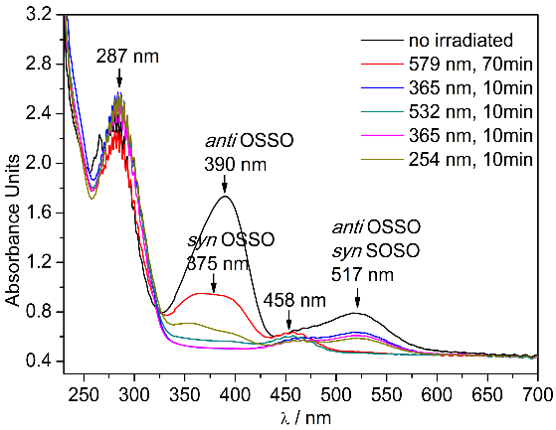 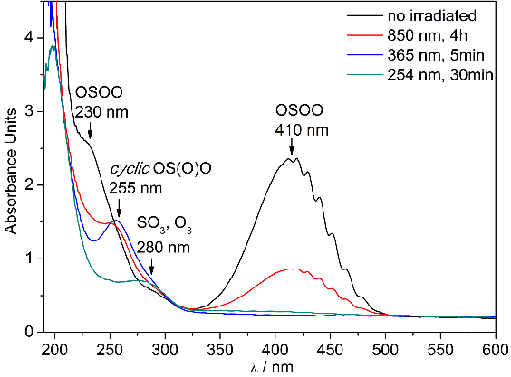

Figures 1 and 2. UV/vis spectra of S2O2 and SO3 isomers.

References:

[1] C. T. Russell, M. G. Kivelson, *Science* **287**, 1998 (2000).

[2] Xi Zhang, Mao-Chang Liang, Franck Montmessin, Jean-Loup Bertaux, Christopher Parkinson, Yuk L. Yung, *Nat. Geosci.* **3**, 834(2010).

[3] Zhuang Wu, Ruijuan Feng, Bo Lu, Jian Xu, Yan Lu, Huabin Wan, André K. Eckhardt, Peter R. Schreiner, Changjian Xie, Hua Guo, Xiaoqing Zeng, *Chem. Commun.* **54**, 1690(2018).

[4] Zhuang Wu, Huabin Wan, Jian Xu, Bo Lu, Yan Lu, André K. Eckhardt, Peter R. Schreiner, Changjian Xie, Hua Guo, Xiaoqing Zeng, *Chem. Commun.* **54**, 4517(2018).

***E-4***

# Spectroscopic Studies of Luminescent Crystals Containing Trivalent Lanthanides

Bor-Chen Chang

*Department of Chemistry, National Central University, Jhongli 32001, Taiwan.*

Our interest is centered on the spectroscopy of luminescent crystals containing trivalent lanthanides and the related energy transfer processes. The spectroscopy of lanthanides provides crucial data that help to determine the crystalline structure of these compounds. [1] The energy transfer processes in these compounds are also very fascinating. The K4[(UO2)Eu2(Ge2O7)2] compound represents a prototype, which exhibits surprisingly strong emission at red wavelengths due to the efficient uranyl (UO22+)→Eu3+ energy transfer. [2] In addition, several energy transfer processes were found in the R2(C8H10O4)3 (R= Y, Eu, Tb, or Sm; C8H10O4= 1,4-cyclohexanedicarboxylate, CHDC) coordination polymers. The photoluminescence (PL), excitation, and time-resolved spectra of these compounds were recorded and analyzed. The analysis shows that in the YEuxTb1-x(CHDC)3 compounds, Tb3+→Eu3+ energy transfer can occur only in the adjacent luminescent centers with a very fast transfer timescale (< 10 μs), while in EuxTb2-x(CHDC)3 this energy transfer is much slower (> 50 μs) due to a Tb3+→Tb3+ energy diffusion following by the Tb3+→Eu3+ energy transfer. Kinetics models were adopted to fit the emission decay and rising curves. The related rate constants and physical parameters can be obtained for interpreting the energy transfer mechanisms and efficiency. On the other hand, when Eu3+ is replaced by Sm3+ in these compounds, despite of the similar properties and energy levels between Eu3+ and Sm3+, complicated emission quenching porcesses were observed.

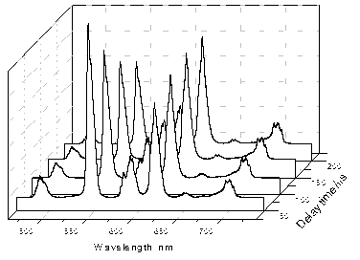

Fig. 1: Time-resolved emission spectra of Eu0.04Tb1.96(CHDC)3 at 303 nm excitation.

References:

[1] P.-L. Chen, P.-Y. Chiang, H.-C. Yeh, B.-C. Chang, K.-H. Lii, *Dalton Trans.* 1721 (2008) and references therein.

[2] S.-P. Liu, M.-L. Chen, B.-C. Chang, K.-H. Lii, *Inorg. Chem.* **52**, 3990 (2013).

***E-5***

**Quantum Vibration Perturbation Theory:  
A Way of Systematically Improving the Accuracy   
in Simulating Infrared Probe Spectra**

Yu Zhai*,1, Yang Cong*,1, Adam Grofe1, Jiali Gao†,2, and Hui Li†,1,

*1 Laboratory of Theoretical and Computational Chemistry,  
 Institute of Theoretical Chemistry, Jilin University,   
2519 Jiefang Road, Changchun 130023, People’s Republic of China*

*2 Department of Chemistry and Supercomputing Institute, University of Minnesota,   
207 Pleasant Street, SE, Minneapolis, MN 55455, U.S.A*

* Contributed equally to this work.

† Email: gao@jialigao.org; prof_huili@jlu.edu.cn

Quantitatively predicting vibrational spectra in complex systems has been an unsolved and absorbing topic for long time. Although a number of methods have been developed, however, during a time when computers were less powerful than nowadays, many approximations had to be made in previous methods, which resulted in inherent inaccuracies. In this work, we further develop the Quantum Vibration Perturbation (QVP) method, which combines molecular quantum vibration and molecular dynamics with perturbation theory. In this framework, first, a Newtonian molecular dynamics simulation is performed, followed by a substitution process to insert molecular quantum vibrational wave functions into the trajectory. The instantaneous vibrational frequency shift on every time step is then calculated using Rayleigh-Schrödinger perturbation theory, where perturbation operator is difference in the potential energy. Finally, semi-classical statistical mechanics is used to get experimentally comparable spectral line shapes. We validated our method using HCOOH·*n*H2O (*n* = 1–2) clusters and HCOOH aqueous solution as examples. It turned out that the QVP method can be used to quickly predict vibrational spectra in complex systems with spectroscopic accuracy.

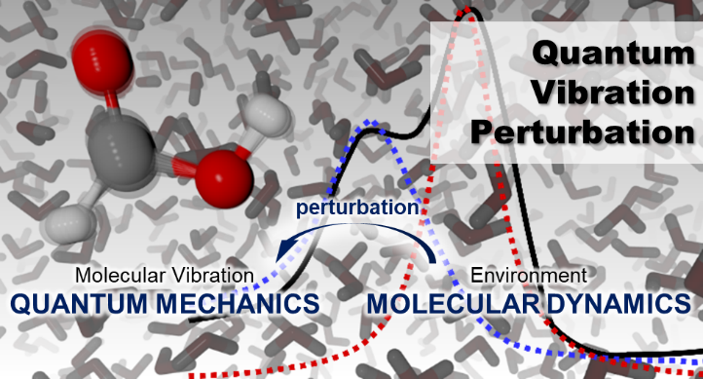

Fig. 1: Quantum Vibration Perturbation method (QVP): Combine quantum mechanics and molecular dynamics together to obtain simulated vibrational spectra.

References:

[1] Rui-Jie Xue et al., *J. Chem. Theory Comput.* **13**, 191 (2017).

[2] Courtney M. Olson et al., *J. Chem. Phys.* **147**, 124302 (2017).

[3] Yang Cong, Yu Zhai, Adam Grofe, Jiali Gao and Hui Li, *to be submitted* (2019).

***F-1***

**Vacuum Ultraviolet Free Electron Laser-Based Infrared Spectroscopy of Neutral Water Clusters**

Ling Jiang

*State Key Laboratory of Molecular Reaction Dynamics, Dalian Institute of Chemical Physics, Chinese Academy of Sciences, 457 Zhongshan Road, Dalian 116023, China*

Dalian Coherent Light Source (DCLS) delivers the Vacuum Ultraviolet Free Electron Laser (VUV-FEL) with high brightness and ultrafast laser pulses in the 50-150 nm wavelength region in picoseconds or 100 femtoseconds, which is an ideal light source for the ionization of molecular systems and the excitation of valence electrons with very high efficiency. DCLS is operated in the mode of High Gain Harmonic Generation (HGHG), which is beneficial to narrow bandwidth, stable power, and low cost due to fewer undulators. The VUV-FEL power for individual pulse at 133 nm approached more than 200 microJoules. The user experiment started in June, 2017. It is open for good proposals from the whole world. In this talk, we will present the commission and main specifications of DCLS, and the first experiment of VUV-FEL-based infrared spectroscopy of neutral water clusters.

***F-2***

**Rotational spectroscopy of the n-propylamine-water complex**

Yang Zheng,1 Juncheng Lei,1 Lorenzo Spada,2 Gang Feng,1 Qian Gou1*

*1 College of Chemistry and Chemical Engineering, Chongqing University, No.55 Daxuecheng South Rd., Shapingba, Chongqing, China*

*2 Scuola Normale Superiore, Piazza dei Cavalieri 7, 56126 Pisa, Italy*

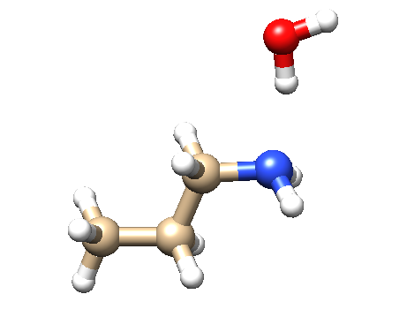Abstract: The rotational spectra of three conformers between n-propylamine (PPA) and water have been characterized in gas using Fourier transform microwave spectroscopy (FTMW). These three observed conformers (Tg-W, Tt-W and Gt-W) are primarily stabilized through the classic O-H•••N hydrogen bond. It is noteworthy that for the Tt-W and Gt-W conformers, only *u*a-type transitions were detected, although the theoretical calculations predicted large dipole moment values of *u*b. This may arise from some large amplitude motion in the two conformers.

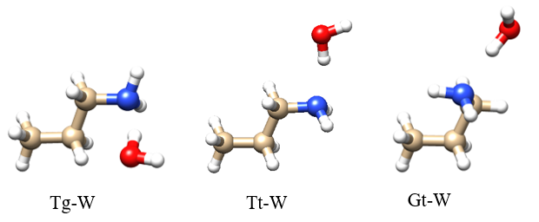

Fig. 1: Three observed conformers of PPA-Water in experiments using FTMW technique.

***F-3***

# Theoretical Investigations of the Optical Properties of Helicene-Iridium Complexes

Qin Yang, Marco Fusè, Franco Egidi, Julien Bloino

*Scuola Normale Superiore, Piazza dei Cavalieri 7, 56126 Pisa, Italy*

Iridium complexes are known for their bright phosphorescence, which finds multiple applications such as organic light emitting diodes (OLEDs) and biomarkers. Their basic optical properties and efficiency can then be tuned by substituting the ligands of the metal center. Recently a new family of molecules (KC and KD, see Fig. 1) containing a helicene ligand (KB) was reported with a long-lasting, bright phosphorescence[1]. However, the exact nature and origin of the enhancement were not fully identified. Such insight can be readily provided by computational chemistry.

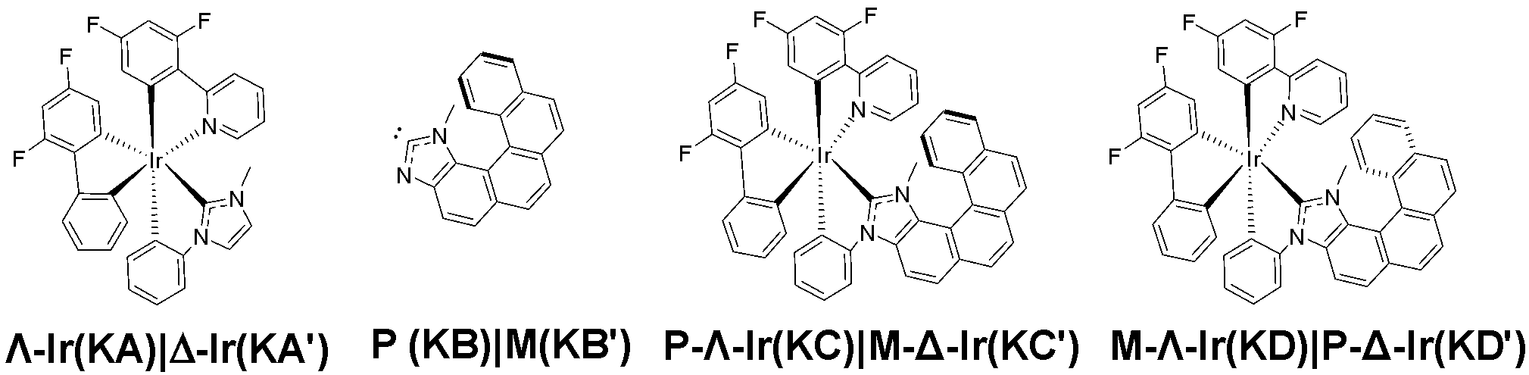Chiral spectroscopies, namely electronic circular dichroism (ECD) and circularly polarized phosphorescence (CPP), are the methods of choice for such a study. But their sensitivity poses a number of challenges to standard electronic calculations. First, the presence of two sources of chirality – the chiral center on Ir and the chiral axis related to the helicene ligand – demands a proper description of the electronic structure of the whole system, with a correct account of relativistic effects[2]. This task is further complicated by the need to correctly describe the recorded band-shape, where vibronic effects can have a large impact. [3-5] The need for accuracy is however hampered by the size of the systems of interest and the number of electronic transitions to take into account. Here, we will present a cost-effective procedure able to reproduce the experimental band-shape. We will describe its strengths and the possible routes for improvement. The achieved result will also permit us to analyze and discuss the origin and nature of the enhancement supported by novel, graphical tools to help the interpretation.

Fig. 1: The structure of KA, KB, KC, and KD

References:

[1] N. Hellou, M. Srebro-Hooper, L. Favereau, F. Zinna, E. Caytan, L. Toupet, V. Dorcet, M. Jean, N. Vanthuyne, J.G. Williams, and L. Di Bari, J. Autschbach and J. Carassous, *Angew. Chemie. Int. Ed.* **28**, 8348 (2017).

[2] F. Egidi, S. Sun, J.J. Goings, G. Scalmani, M.J. Frisch and X. Li, *J. Chem. Theory Comput.* **13**, 2591 (2017).

[3] J. Bloino, A. Baiardi and M. Biczysko, *Int. J. Quantum Chem.* **116**, 1543 (2016).

[4] J. Bloino, M. Biczysko, F. Santoro and V. Barone, *J. Chem. Theory Comput.* **6**, 1256 (2010).

[5] F. Egidi, M. Fusè, A. Baiardi, J. Bloino, X. Li and V. Barone, *Chirality* **30**, 850 (2018).

***F-4***

**Molecular systems under external stimuli**

Malgorzata Biczysko

*Shanghai University, 99 Shangda Lu, Shanghai 200444, China*

Structural and conformational changes in molecular systems can be initiated and controlled by external stimuli, such as thermal variations or interaction with MIR to UV light. The irradiation can affect molecular motion through a direct promotion into an electronically excited state followed by a significantly different interaction with its local environment and/or the excitation of vibrational modes (fundamental bands or overtones) of the electronic ground state, opening the possibility to redistribute energy over different degrees of freedom in the system via internal energy relaxation processes.

The state-of-the art experimental investigations of “in situ” processes initiated by external stimuli, either thermal energy or tunable light irradiation, can be monitored by combining FTIR spectroscopy with matrix isolation techniques. Together with the top level experimental instrumentation, theoretical and computational studies are needed in order to understand and resolve thoroughly the processes and phenomena taking place in the experiments. Theoretical studies can also guide experiments suggesting most suitable energy ranges allowing for production of new species, via MIR, NIR, visible or UV irradiation, i.e. excitation of specific vibrational or vibronic transitions allowing to overcome barriers for conformational change or bond breaking.

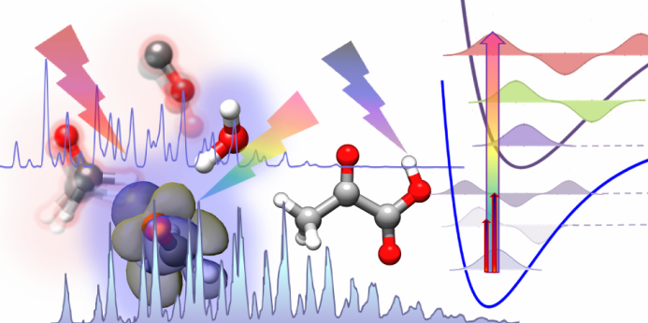This talk will highlight that reliable theoretical support requires going beyond the most standard computational procedures by including anharmonic and vibro-electronic effects on both band positions and transition intensities.

References:

[1] J. Bloino, A. Baiardi, M. Biczysko*, Int. J. Quantum Chem*. **116**, 1543 (2016)

[2] M. Biczysko, J. Bloino, C. Puzzarini, *WIREs Comput Mol Sci* **8**, e1349. (2018)

[3] M. Biczysko, J. Krupa, M. Wierzejewska, *Faraday Discuss.* **212**, 421 (2018)

[4] I Reva, C M. Nunes, M Biczysko, R Fausto, *J. Phys. Chem. A*, **119**, 2614 (2015)

[5] E. E. Najbauer, G. Bazso ́, R. Apostolo, R. Fausto, M. Biczysko, V. Barone, G. Tarczay *J. Phys. Chem. B*, **119**, 10496 (2015)

***G-1***

**Dissociation energy of molecular hydrogen at 10-9 accuracy**

C. –F. Cheng1, J. Hussels2, E. J. Salumbides2, H. L. Bethlem2, S. –M. Hu1, K. S. E. Eikema2, W. Ubachs2

*1Department of Chemical Physics, University of Science and Technology of China*

*2Atomic, Molecular and Laser Physics, Vrije Universiteit Amsterdam*

The dissociation energy (D0) of H2 is a benchmark value in quantum chemistry [1], with recent QED calculations now approaching accuracies achievable in simple atoms. Precise measurement of the GK-X molecular transition, in combination with other precision measurements [2], provides a determination of D0. The GK-X transition is excited through Doppler-free two-photon spectroscopy using 179-nm radiation, based on frequency up-conversion using a special KBBF crystal. The optical frequency of the fundamental (716 nm), which is the output of a narrowband pulsed Ti:Sa laser system, is locked to a frequency comb. This enables accuracies of the GK-X transition to a few parts in 1010 or MHz level, leading to an order-of-magnitude improvement for D0. The comparison of this accurate experimental result with the best calculations may provide a test of the Standard Model of Physics.

References:

[1] G. Herzberg, *J. Mol. Spectrosc.* **33**, 147 (1970).

[2] C. –F. Cheng, J. Hussels, et al, *Phys. Rev. Letts.* 1**21**, 013001 (2018).

***G-2***

**Electronic transitions of ScO in the UV region**

A. S.-C. Cheung1, Y.W. Ng1, Na Wang1 and Wenli Zou2

1*Department of Chemistry, The University of Hong Kong, Pokfulam Road, Hong Kong*

2*Institute of Modern Physics, Northwest University, Xi’an, China.*

Laser excitation spectra of the scandium monoxide (ScO) molecule in the ultra violet (UV) region between 280 and 320 nm have been recorded and studied using optical-optical double resonance (OODR) spectroscopy and laser induced fluorescence (LIF) spectroscopy. The ScO molecule was prepared by the reaction of laser ablated yttrium atom with oxygen under supersonic jet cooled conditions. We gain access to electronic states in the UV region via an intermediate B2Σ+ state using OODR spcetroscopy. The B2Σ+–X2Σ+ transition of ScO was pumped by an optical parametric oscillator (OPO) laser and further excitation was acheived using a tunable dye laser to the UV region. Besides, LIF spectra of the ScO molecule are obtained by direct excitation to higher energy electronic states using the OPO laser. Eleven vibrational bands have been observed of which seven belong to four transition systems namely: Ω’ = 0.5 – B2Σ+, Ω’ = 1.5 – B2Σ+, 2Σ+ – B2Σ+ and a forbidden 4Σ+ – 2Σ+ transitions. The excited states analyzed so far are generally in good case (c) coupling scheme. Molecular constants for the observed electronic states were determined by least squares fitting of the measured rotational lines.

52 low-lying Λ-S states of ScO below 50000 cm-1 have been calculated using SA-CASSCF (state-averaged complete active space self-consistent field) followed by CASPT2 (complete active space 2nd order perturbation theory) and MS-CASPT2 (multi-state CASPT2). The active space consists of 7 electrons in 12 orbitals corresponding to Sc 3*d*4*s*, O 2*p*, and the mixed shells by Sc 4*p* and O 3*s*3*p* where the latter active orbitals may improve the convergence of SA-CASSCF. Scalar relativistic effects are taken into account via the DKH2 (2nd-order one-electron Douglas-Kroll-Hess) Hamiltonian, and the standard ANO-RCC-VQZP (relativistic contracted correlation-consistent atomic natural orbital in 4-ζ quality) basis set is used for Sc and O. In addition, spectroscopic properties of low-lying Ω sub-states have also been calculated, the spin-orbit coupling (SOC) is treated via the state-interaction (SI) approach with the AMFI (atomic mean field integral) approximation for one- and two-electron spin-orbit integrals. A comparison of the spectroscopic properties of the electronic states determined experimentally and those from calculations will be presented.

***G-3***

# A new 4  ai Electronic Transition of ScC in the near infrared

Chiao-Wei Chen, Anthony J. Merer, Yen-Chu Hsu

*1Department of Physics, National Central University, 300 Jongda Rd. Jongli district, Taoyuan City, 32001, Taiwan*

A new   a4i electronic transition of ScC in the near IR has been discovered, following the reaction of laser-ablated scandium metal with acetylene under jet-cooled conditions. The (0,0) band at 12720 cm is too weak for rotational analysis in our experiments, but assignments have been possible for the (1,0) and (2,0) bands at 13326 and 13924 cm. The a lower state is metastable, and from previous work[1] its 45/2 spin component is known to lie 156 cm above the X23/2 ground state. At the low temperature of our jet experiments, only the 45/2 spin component has significant population. The branch structure of the   a45/2 sub-band is dense and its assignment required the use of a specially-written band contour programme. A full analysis of the rotational and spin structure of the 4 state could then be carried out; for the (1,0) band the B′ value is 0.4558 cm, and the two principal upper state spin constants are  = 0.451 cm and  = 0.022 cm. The spin constants are essentially unchanged on vibrational excitation, and the vibration-rotation constant  is 0.0066 cm. These values are confirmed by the observation of a few weak lines from the 3/2 and 41/2 spin components. Extrapolating to the v=0 level of the 4 state, the bond length, r0, is 1.962 Å. There is no information in the spectrum that tells whether the upper state is 4+ or 4.

References:

[1] C-W. Chen, A.J. Merer and Y-C. Hsu. J. Chem. Phys. **149**, 074302 (2018).

***G-4***

**Infrared Spectroscopy of TiO in a supersonic jet expansion**

Daniel Witsch1, Alexander A. Breier1, Björn Waßmuth1, Guido W. Fuchs1, Thomas F. Giesen1

*1University of Kassel, Laboratory Astrophysics, Heinrich-Plett-Str. 40, 43132 Kassel, Germany*

Interstellar dust plays an important role in the chemical evolution of the interstellar medium. However, the dust formation itself is barely understood. Refractory elements such as titanium bearing molecules are forming at temperatures around a few thousand Kelvin and are considered to contribute to the chemistry in the dust formation region around late-type stars. Recently, TiO and its isotopologues have been detected towards oxygen rich late-type stars, such as Mira or VY Canis Majoris, at sub-mm [1,2] and optical wavelength [3]. In view of a new generation of high resolution infrared instruments for astronomical observations, e.g. EXES onboard SOFIA or HIPWAC at the Subaru telescope, rotationally resolved infrared spectra of molecules containing refractory elements are of high demand.

In this contribution, we present the first rotationally resolved infrared spectrum of titanium monoxide (TiO). The molecules are formed using laser ablation of a titanium sample in an atmosphere of N2O, which is diluted in a helium buffer gas. Subsequent adiabatic expansion cools down the molecules to rotational temperatures of a few tens of Kelvin, thus forming a supersonic jet. Radiation of a 10 micron quantum cascade laser (QCL) probes the TiO cluster-pulse in a collision free region, the so-called *zone of silence*. During the 10 µs cluster-pulse, the frequency of the QCL is rapidly tuned in frequency, recording a spectral interval of 0.03 cm-1 bandwidth. Each interval is averaged about 600 times, before stepping to the next interval. Combining all the spectral intervals results in a rotationally resolved infrared spectrum of TiO. The sensitivity of the instrument is high enough to measure the hot band transitions and isotopologues of TiO in natural abundance.

References:

[1] T. Kaminski *et al.*, *A&A* **551**, A113 (2013).

[2] T. Kaminski *et al.*, *A&A* **599**, A59 (2017).

[3] J. Chavez *et al.*, *Ap. J.* **699**, 1906 (2009)

***G-5***

**Line intensities of the radioactive isotopologues of the carbon monoxide molecule**

Valerii I. Perevalov1, Ekaterina V. Karlovets1,2

*1Laboratory of Theoretical Spectroscopy, V. E. Zuev Institute of Atmospheric Optics, Siberian Branch, Russian Academy of Sciences, 1, Akademician Zuev sq., 634055, Tomsk, Russia*

*2Tomsk State University, Laboratory of Quantum Mechanics of Molecules and Radiative Processes, 36, Lenin Avenue, 634050, Tomsk, Russia*

The infrared absorption line intensities of the radioactive species of the carbon monoxide molecule are known only after the theoretical calculations [1]. No observed values are published. For the validation of the published values we performed the calculations of the line intensities of these radioactive species using the alternative method, namely method based on the isotopic substitution relations for the effective dipole moment parameters. The infrared absorption line intensity of a heterogenic diatomic molecule is proportional to the transition dipole moment squared. The latter for the transition can be written in the form



Here  is the vibrational transition dipole moment,  is the known function of the vibrational quantum number ,  is Hönl-London factor, where  is angular momentum quantum number, parameter  describes the dependence of the vibrational transition dipole moment on vibrational quantum number,  and  are the Herman-Wallis parameters. The ,  and parameters were fitted to the observed line intensities taken from the literature for the 1-0, 2-0, 3-0 bands of the principal isotopologue. Then we have derived the isotopic substitution equations for these parameters. Using these equations we calculated the above parameters for the rare isotopologues of carbon monoxide including the radioactive ones. The line intensities of some rare isotopologues calculated using the effective dipole moment parameters of the principal isotopologue and derived isotopic substitution equations were compared to the observed values and to the earlier calculated values [1]. The line intensities of the radioactive species of carbon monoxide were compared to the calculated values from Ref.[1]. The results of the comparisons are presented in the present talk.

Reference:

[1] G. Li, I.E. Gordon, L.S. Rothman, Y. Tan, S.-M. Hu, S. Kassi, A. Campargue, E.S. Medvedev, *Astrophys. J. Suppl. Ser.* **216**,15 (2015).

***H-1***

# Conversion dynamics of nuclear spin isomers of the CH3OH molecule in the gas phase

Zhen-Dong Sun1,2*, Li-Sha Ma1, Yunhu Wu2, and Pavel L. Chapovsky3

*1School of Physics, Shandong University, Jinan 250100, China*

*2School of Physics and Electrical Engineering, Kashgar University, Kashgar 844006, China*

*3Institute of Automation and Electrometry, Russian Academy of Sciences, Novosibirsk, 630090, Russian Federation*

*\**Email: [zdsun@sdu.edu.cn](mailto:xuhf@jlu.edu.cn)

There is a CH3-group and an OH-group in the CH3OH molecule, in which they relatively rotate in the opposite directions, displaying internal rotation or torsion of the CH3-group with respect to the OH-group and causing numerous subtle torsion-mediated rotation–torsion–vibration energies. Due to the different spatial orientations of the nuclear spins in three equivalent hydrogen nuclei of the CH3-group, the CH3OH molecule is composed of the ortho-CH3OH and para-CH3OH isomers which are combined with the states of *A* and *E* torsional symmetry, respectively.

Recent spectroscopic observation has shown the phenomenon of interconversion between the ortho-CH3OH and para-CH3OH [1]. In this work, we, in the framework of the quantum relaxation [2], theoretically studied on the underlying conversion dynamics of two spin isomers of the CH3OH molecule in the gas phase. We think that the intermolecular collisions cause the interconversion between the ortho-para methanol molecules among nuclear spin-torsion-specific near-denegerate enegy levels of the *A*−*E* species mixed by weak intramolecular hyperfine potentials. We have analytically deduced the expressions of the quantum perturbation matrices induced by the nuclear spin−spin interaction and nuclear spin−rotation interaction, respectively. We have obtained the corresponding formulas of the conversion rates in an exponential description of a non-equilibrium concentration of the ortho-CH3OH. Under the experimental condition of gas pressure at 1 Torr and sample gas temperature at 300 K, we have numerically calculated the ortho-para conversion rates for eight ortho-para level pairs with gaps less than 2.7 GHz and allowed by the selection rules of |Δ*J|* ≤ 2 and |Δ*K*| ≤ 2. The total conversion rate is calculated to be 1.87 × 10-2 s-1, which is close to the measured value of 2.10 × 10-2 s-1 with a relative error of 11%, suggesting the quantum relaxation is the leading process in the interconversion between the ortho-CH3OH and para-CH3OH in the gas phase.

References:

[1] Z.-D. Sun, M. Ge, and Y. Zheng, *Nat. Commun.* **6**:6877 (2015).

[2] P. L. Chapovsky, *Phys. Rev. A* **43**, 3624 (1991).

Acknowledgements：This research was partially supported by NSFC (Nos. 91536105, 11174186, and 11074147), FSRPHEXJ (No. XJEDU2016I041), and the Tianshan Scholar Program.

***H-2***

**Spectral Characterization of Three-Electron Two-Center (3e-2c) Bonds of Gaseous CH3SH Clusters**

Min Xie1, 3, Asuka Fujii2, Yuan-Pern Lee3

*1 MOE Key* *Laboratory of Laser Life Science & Institute of Laser Life Science, College of Biophotonics, Guangzhou Key Laboratory of spectral analysis and functional probes, South China Normal University, Guangzhou, 510631, China; 2 Department of Chemistry, Graduate School of Science, Tohoku University, Sendai 980-8578, Japan; 3 Department of Applied Chemistry and Institute of Molecular Science, National Chiao Tung University, 1001, Ta-Hsueh Road, Hsinchu 30010, Taiwan*

The three-electron two-center (3e-2c) bond plays an important role in structures and electron communication in biological systems involving cationic sulfur compounds. A direct spectral identification of 3e-2c-bound clusters of CH3S-S(H)CH3 and (CH3SH)n+, *n* = 2-6, in a supersonic jet was performed with infrared (IR) dissociation upon vacuum-ultraviolet photoionization and time-of-flight detection. We produced CH3S-CH3SH on irradiation of a supersonic jet of CH3SH clusters with light at 248 nm from an excimer laser. (CH3SH)n+, *n* = 2-6, were generated through the ionization of (CH3SH)n+, *n* = 2-6, respectively, in the ionization region of a TOF mass spectrometer. IR action spectra of CH3S-S(H)CH3 and (CH3SH)n+, *n* = 2-6, were measured in the S-H and C-H stretching regions from 2400 to 3100 cm-1. The observed IR spectra indicate that both CH3S-S(H)CH3 and (CH3SH)2+ are mainly 3e-2c-bound, rather than hydrogen bonded. Protonation of CH3S∴S(H)CH3 to form [CH3(H)S∴S(H)CH3]+ significantly enhances the 3e-2c bond, characterized by a large red shift of the SH-stretching band with enhanced IR intensity, a shortening of the calculated S−S distance from 3.00 to 2.86 Å, and a dissociation energy increased from ~23 to 162 kJ mol−1. The IR spectral features of the free SH stretch of the ion core indicate that the 3e-2c-bound motif of the ion core is maintained up to the completion of the first H-bonded solvation shell when the size of the CH3SH cluster reaches to 4. In the larger clusters, the 5th and 6th molecules bind to the ion core mainly via the charge-induced dipole interactions. This study reveals the spectral characteristics and the solvation of the 3e-2c structure.

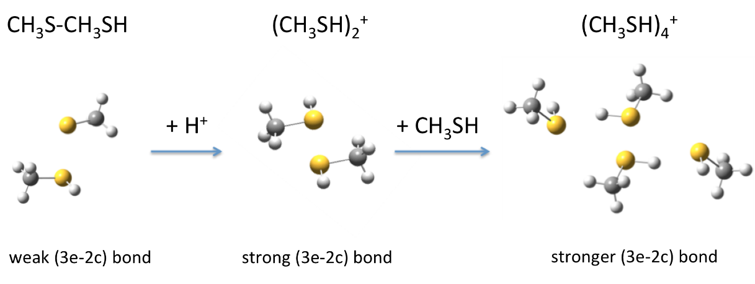

***H-3***

**Sulfur hydrogen bonding: diethyl disulfide-H2O dimer in gas phase studied by microwave spectroscopy**

Xiaolong Li1, Daniel A. Obenchain2, Jiaqi Zhang1, Sven Herbers2, Qian Gou1,Gang Feng1, Jens-Uwe Grabow2

*1Department of Chemistry, School of Chemistry and Chemical Engineering, Chongqing University, Daxuecheng South Rd. 55, 401331, Chongqing, China.*

*2Institut für Physikalische Chemie and Elektrochemie, Gottfried Wilhelm Leibniz Universität Hannover, Callinstraße 3A, 30167, Hannover, Germany.*

The rotational spectra of diethyl disulfide-H2O complex are investigated by a coaxially oriented beam-resonator arrangement type supersonic-jet Fourier microwave spectrometer with combination quantum chemical calculation. The rotational spectra of parent species, H218O, D2O, HOD and DOH isotopologues are assigned. The experiment, non-covalent interaction (NCI) and the Symmetry-Adapted Perturbation theory (SAPT) analysis identify that two moieties are mainly linked by an OH···S hydrogen bond, which is determined as 2.483(12) Å by rotational constants of five isotopologues.

***H-4***

**QVP Theory: Application to the Sum Frequency Generation**

J-T. Yang, Hui Li1

*1Institute of Theoretical Chemistry Jilin University, 2519 Jiefang Road, Changchun 130023, People’s Republic of China*

The sum frequency spectrum (SFG) is an interface/surface spectrum technology that has developed rapidly in recent years. To interpret the spectra from experiments, many theoretical methods have been proposed and several formalisms have been deduced: 1) the fraction formalism [1]; 2) time-dependent formalism developed by Morita and Hynes [2] which add some classical approximation on the fraction formalism, easily to accomplish but lacking of quantum corrections; 3) mixed quantum/classical approach developed by Skinner, which also add some classical approximation, at the same time the chromophore is treated quantum mechanically and motional narrowing considered [3]. No matter what the formalism we take, it is essential that use accurate electronic properties, for which can change with time and surrounding environment, and are written in all formalisms explicitly. Here, a new method is introduced. In this method, the quantum vibration perturbation (QVP) method applies to calculate the instantaneous vibration frequency and electronic properties of each molecular dynamics (MD) time step. i.e. these electronic properties are treated quantum mechanically in a relative accurate way and the surrounding is considered at the same time. Then, we can take the formalism we want to calculate the SFG spectrum. We took the acetonitrile solution as the test system. Three different formalisms are used for comparison studying. Nuclear quantum effects and sampling from different depths to generate SFG spectra are discussed in this work.

References:

[1] A. Morita and J. T. Hynes, *Chem. Phys*. **258,** 371 (2000)**.**

[2] A. Morita and J. T. Hynes, *J. Phys. Chem. B* **106**, 673 (2002).

[3]B. M. Auer and J. L. Skinner, *J. Chem. Phys.* **129***,* 214705 (2008).

***H-5***

**Amyloid Fibrillation of Hen Egg White Lysozyme Accelerated by Succinimide**

Wei Fan, Lei Xing, Mengna Li, Ning Chen, Xiaoguo Zhou*, Shilin Liu*

*Hefei National Laboratory for Physical Sciences at the Microscale, iChEM (Collaborative Innovation Center of Chemistry for Energy Materials),*

*Department of Chemical Physics, University of Science and Technology of China, Hefei 230026, China.*

C:\Users\lclab\Desktop\fig11-纤维化机理.tifProtein aggregation with the concomitant formation of amyloid fibrils is associated with a series of neurodegenerative diseases. It is of great significance for understanding the mechanism of protein fibrosis and improving the treatment of diseases. In previous studies, it was shown that the toxicity of protein fibrosis to organisms mainly result from prefibrillar assemblies of proteins, such as soluble oligomers or protofibrils, since the final mature fibrosis is relatively non-toxic. Therefore, shortening period of protein fibrosis is one way to reduce its toxicity. In this work, using hen egg white lysozyme (HEWL) as a model protein, the role of succinimide on protein fibrosis process was investigated with a combination of several experimental techniques, including Fluorescence probe thioflavin T (ThT), far-UV CD, atomic force microscopy (AFM) and Raman spectroscopy. The results show that the succinimide can effectively shorten the period of oligomer and promote protein fibrosis. This promotion is attributed to that succinimide destroy the stable structure of natural proteins, such as disulfide bonds, hydrogen bonds formed by tryptophan. At the same time, in the state of fibrosis, succinimide links different protein molecules by forming a cationic π interaction with tryptophan.

Fig. 1:The transformation mechanism of amyloid fibrillation of lysozyme.

References:

[1] Kocherbitov, V.; Niaura, G. The journal of physical chemistry. B2013, 117, 4981.

[2] Shashilov, V.; Lednev, I. K. Journal of the American Chemical Society2007, 129, 6972.

***I-1***

**Is the OH Stretching Vibrational Transition Moment of Simple Molecules Aligned Along the OH Bond?**

Kaito Takahashi1

*1Institute of Atomic and Molecular Sciences, Academia Sinica, No. 1 Sec. 4 Roosevelt Rd. 10617, Taipei Taiwan*

When analyzing the experimental vibrational peak position of OH stretching vibrations of simple molecules, the local mode picture has great success. In addition, the bond dipole approach has helped analyze the peak intensities, where the transition dipole of the OH stretching mode is assumed to be only along the OH bond. In this talk, we will show that the actual transition moment for the OH stretching vibration of HOD is not aligned exactly along the OH bond. Furthermore, we will show that the direction will change as a function of the vibrational excitation quantum number. This trend is also seen for other molecules such as CH3OH, HNO3, as well as CH3COOH. We will argue that this tilting of the vibrational transition moment is related to the lone pair electrons on the oxygen atom. Therefore, we will theoretically show that if one can pin the lone pair electrons on the oxygen atom one may be able to control the direction of the transition moment of the OH stretching vibration. Furthermore, for H2O we present a simple model that relates the tilt angle of the local OH stretching vibration transition moment to the ratio of the symmetric and asymmetric stretching vibration peak intensity. Using this model, we propose experiments to verify that the OH stretching transition moment will stay aligned along the OH bond if the lone pair electron is pinned.

References:

[1] Kaito Takahashi, Michihiko Sugawara, and Satoshi Yabushita, *The Journal of Physical Chemistry A*, **109**, 4242-4251 (2005).

***I-2***

**Near-IR spectroscopy of Radicals using cw-CRDS coupled to Laser photolysis**

Christa Fittschen

*University Lille – CNRS, Physical Chemistry of Combustion and Atmospheric Processes, Lille, France*

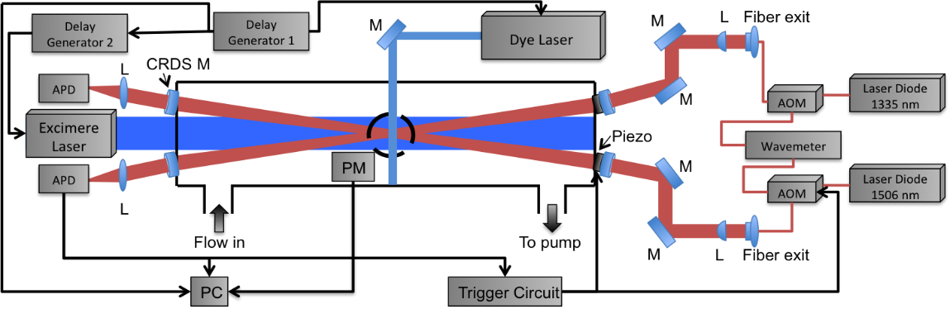Radicals are key species in many chemical processes such as combustion or atmosphere. Their selective, sensitive and quantitative detection is highly desired in order to investigate such processes. We have set-up an experimental technique that combines a pulsed generation of radicals by laser photolysis with a time-resolved detection of radicals by cw-CRDS in the near IR region: two absorption paths are installed in a small angle with respect to the photolysis laser. A high repetition rate laser induced fluorescence (LIF) allows the time-resolved relative detection of a third species.

Using this set-up, absorption spectra of reactive species can be measured as depicted in the figure: ring-down times are measured relative to the photolysis pulse, and the average ring-down time before the photolysis pulse (black symbols) is the baseline, extrapolation of ring-down time to t=0 after the photolysis pulse (green symbols) gives absorption of radicals and allows calculating the absorption coefficient (red symbols). Well designing the experimental conditions and exploring the time-resolution has allowed us determining concentrations of different radical (HO2, DO2, OH, CH3O2, CH3COO2) and molecular species (CH2O, H2O2, HONO) and thus obtaining their absolute absorption cross sections, e.g. [1]-[3]. Examples will be presented at the conference.

References:

[1] E. Assaf, O. Asvany, O. Votava, S. Batut, C. Schoemaecker, C. Fittschen, *J. Quant. Spectrosc. Radiat. Transfer* **201,** 161-170 (2017); [2] E. Assaf, C. Fittschen, *J. Phys. Chem. A* **120**, 7051-7059 (2016); [3] A. Ruth Albert, U. Heitmann, E. Heinecke, C. Fittschen, *Z. Phys. Chem*. **229,** 1609 (2015); [4] C. Jain, P. Morajkar, C. Schoemaecker, B. Viskolcz, C. Fittschen, *J. Phys. Chem. A* **115**, 10720 (2011)

***I-3***

**A proposal for laser directly cooling AgH & AgD radicals**

Chuanliang Li1, Yachao Li1, Zhonghua Ji2, Xuanbing Qiu1, Yanting Zhao2, Jinjun Liu3

*1Department of Physics, School of Applied Science, Taiyuan University of Science and Technology, China*

*2 State Key Laboratory of Quantum Optics and Quantum Optics Devices, Institute of Laser Spectroscopy, Shanxi University, China*

*3 Department of Chemistry, University of Louisville, Louisville, Kentucky 40292, USA*

We propose to utilize the 1Σ - 1Σ electronic transition system for direct laser cooling of heteronuclear diatomic molecules AgH, as well as its deuterium isotopologue AgD. Potential energy curves and relevant molecular parameters of both AgH and AgD, including the spin-orbit constants and the electronic transition dipole moments, are determined in internally contracted multiconguration-reference conguration interaction calculations. The highly diagonal Franck-Condon matrices of the *A*1Σ+ - *X*1Σ+ transitions predicted by the calculations suggest the existence of quasi-closed-cycle transitions, which renders these molecules suitable for direct laser cooling. By solving rate equations numerically, we demonstrated that both AgH and AgD molecules can be cooled from 25 K to 2 mK temperature in approximately 20 milliseconds[1]. Our investigation elucidates and supports the hypothesis that molecules in the simplest 1Σ - 1Σ system can serve as favorable candidates for direct laser cooling.

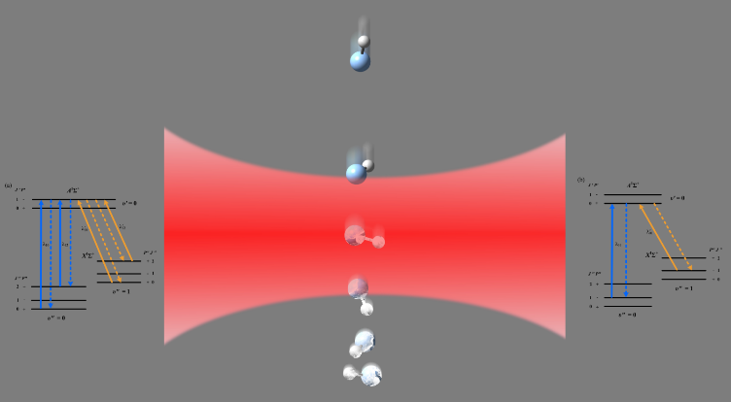

Fig. 1: The abstract may include equations and figures. They should be embedded in the abstract document. Laser-cooling schemes for AgH and AgD molecules in the *A*1Σ+ - *X*1Σ+ system. The dash lines and solid lines represent spontaneous emission and excited lasers, respectively. (Left) Using the (*J*0 = 1 🡨*J*00 = 0) transition; (Right) using the (*J*0 = 0 🡨 *J*00 = 1) transition.

References:

[1] Chuanliang Li, Yachao Li, Zhonghua Ji, Xuanbing Qiu, Yunzhong Lai, Jilin Wei, Yanting Zhao, Lunhua Deng, Yangqin Chen, and Jinjun Liu Phys. Rev. A 97, 062501(2018)

**Acknowledgments**

This work was supported by the National Natural Science Foundation of China (Grant Nos. U1810129, U1610117 & 11504256), Excellent Youth Academic Leader in Higher Education of Shanxi Province (2018), Key Research and Development Program of Shanxi Province of China (Grant Nos. 201803D31077 & 201803D121090), State Key Laboratory of Organic Geochemistry, GIGCAS (Grant No.SKLOG-201715) and the Fund for Shanxi “1331 Project” Key Innovative Research Team (1331KIRT).

***I-4***

**The electronic excited state of C3Ar studied by hole burning spectroscopy and the ab initio calculation**

Yen-Chu Hsu, Yi-Jen Wang

*National Central U., Department of Physics, Jongli, Taiwan,*

*And*

*Institute of Atomic and Molecular Sciences, Academia Sinica, P. O. Box 23-166, Taipei, Taiwan*

The C3Ar van der Waals complex has been studied under supersonic expansion conditions by laser-induced fluorescence and hole burning techniques. The spectrum of the complex consists of a number of pairs of bands accompanying each of the bands of the Ã- $\tilde{X}$ system of C3 [1,2] other than the perturbed 000-000 band. In this work the four longest wavelength pairs at around 25418, 25430, 25505 and 25517 cm-1, are assumed to form vibrational progressions with an upper state frequency of about 12 cm-1. Somewhat unexpectedly, the two lowest pairs near 25418 and 25505 cm-1 exhibit very different dynamics. The two members of the lowest pair have more diffuse rotational structure; also compared to the next pair, their upper states predissociate into lower (by about 100 cm-1) vibrational states of the C3 fragment. A hole burning experiment has been carried out which proves that the lowest pair indeed belongs to C3Ar, and arises from its ground vibrational level. Band contour calculations of the rotational envelopes show that the two lowest rotational pairs have the same upper state symmetries and the rotational constants B' are unusually large, indicating the prescene of Coriolis coupling within the pairs. The 12 cm-1 vibrational frequency is tentatively assigned as two quanta of the out-of-plane bending vibration, based on the analogy of the ground-state vibrational frequency. Band contour simulations of the hole burning spectra and the ab initio calculations of the Ã state of C3Ar at the level of MCSCF-RS2/pVTZ will be presented and discussed.

References,

1. G. Zhang, B.-G. Lin, S.-M. Wen, and Y.-C. Hsu, J. Chem. Phys. 120, 3189-3200(2004).

2. A. J. Merer, Y.-C. Hsu, Y.-R. Chen, and Y.-J. Wang, J. Chem. Phys. 143, 194304(2015).

***P-1***

**Rotational spectrum and non-covalent interaction of isopropylamine-water, an adduct of interstellar interest**

Junhua Chen1, Wanying Cheng1, Meng Li1, Lorenzo Spada2,3, Gang Feng1, Qian Gou1

*1 Department of Chemistry, School of Chemistry and Chemical Engineering, Chongqing University, Daxuecheng South Rd. 55, 401331, Chongqing, China.*

*2 Dipartimento di Chimica “G. Ciamician” dell’Università, Via Selmi 2, I-40126 Bologna, Italy.*

*3 Scuola Normale Superiore, Piazza dei Cavalieri 7, I-56126, Pisa, Italy*.

**Abstract:** The rotational spectrum of water adduct of isopropylamine has been recorded with supersonic jet Fourier transform microwave spectroscopy. Two isomers stabilized by classic hydrogen bond and weak hydrogen bond were observed in supersonic expansion. The most stable isomer denoted *trans* has a water lying in *ac* symmetry plane of the isomer. Transition frequencies, conformational composition, rotational and 14N nuclear quadrupole coupling constants of the adduct have been provided, which should be useful for a potential identification of this adduct in the interstellar medium. The relative intensity measurements on several *a*-type transitions suggested the relative population ratio of the both isomers as *N*trans/*N*gauche ~ 3:1 in the plused jet.

***P-2***

**DFB-QCLs in combination with a pulsed supersonic jet for high resolution infrared spectroscopy**

Wei Luo，Zhuang Liu，Chuanxi Duan*

*1College of Physical Science and Technology, Central China Normal University, Wuhan 430079, China*

Distributed-feedback quantum cascade lasers (DFB-QCLs) in combination with a supersonic molecular beam expansion are a perfect tool for the investigation of molecules, ions, and radicals at low temperatures. Two data acquisition schemes were developed for pulsed supersonic jet infrared laser absorption spectroscopy based on DFB-QCLs: a continuous wave segmented rapid-scan scheme with a moderate vacuum pumping capacity and an intra-pulse rapid-scan scheme with a pulsed supersonic discharge jet. To demonstrate the applicability of DFB-QCLs combine with a pulsed molecular jet for high resolution infrared spectrum, the absorption spectrum of the ν4 fundamental band of HCOOH was recorded by the continuous wave segmented rapid-scan scheme and the absorption spectrum of the discharge products of (Ar+SO2) was obtained by the intra-pulse rapid-scan scheme.

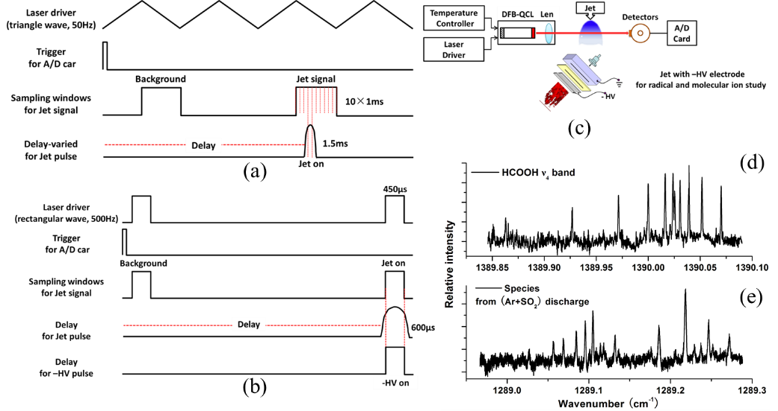

(a) the pulse sequence of continuous wave segmented rapid-scan data acquisition scheme; (b) the pulse sequence of intra-pulse rapid-scan data acquisition scheme; (c) Schematic diagram of the jet-cooled DFB-QCL absorption spectrometer; (d) Spectrum of the *v4* fundamental band of HCOOH recorded by the continuous wave segmented rapid-scan scheme; (e) Spectrum of the expanding discharge products of (Ar+SO2) recorded by the intra-pulse rapid-scan scheme.

**Reference**

[1] [Normand E](https://www.ncbi.nlm.nih.gov/pubmed/?term=Normand%20E%5BAuthor%5D&cauthor=true&cauthor_uid=12656521), [McCulloch M](https://www.ncbi.nlm.nih.gov/pubmed/?term=McCulloch%20M%5BAuthor%5D&cauthor=true&cauthor_uid=12656521), [Duxbury G](https://www.ncbi.nlm.nih.gov/pubmed/?term=Duxbury%20G%5BAuthor%5D&cauthor=true&cauthor_uid=12656521), [Langford N](https://www.ncbi.nlm.nih.gov/pubmed/?term=Langford%20N%5BAuthor%5D&cauthor=true&cauthor_uid=12656521), *Opt. Lett.* 28,16 (2003).

[2] [Wei Luo](https://www.sciencedirect.com/science/article/pii/S0022285217300784#!), [Yulan Zhang](https://www.sciencedirect.com/science/article/pii/S0022285217300784#!), [Wenguang Li](https://www.sciencedirect.com/science/article/pii/S0022285217300784#!), [Chuanxi Duan](https://www.sciencedirect.com/science/article/pii/S0022285217300784#!), *J. Mol. Spectrosc.* 334,22 (2017).

***P-3***

**The aggregation of human islet amyloid polypeptide at lipid membrane is retarded significantly in low pH environment**

Jiahui Zhang1,2, Junjun Tan1,2, Shuji Ye1,2,*

*1Hefei National Laboratory for Physical Sciences at the Microscale, and Department of Chemical Physics, University of Science and Technology of China, Hefei, Anhui 230026, China*

*2 Synergetic Innovation Center of Quantum Information & Quantum Physics, University of Science and Technology of China, Hefei, Anhui 230026, China*

It has been long believed that the misfolding and aggregation of human islet amyloid polypeptide (hIAPP) is closely related to the pathology of type II diabetes. hIAPP keeps its monomeric form when stored in the pancreatic islet β-cells with a concentration as high as 4 mM, while it tends to deposit with a much lower concentration after co-released with insulin to extracellular environment. The pH change from acidic β-cells (~5.5) to neutral fluid (~7.4) may favor the amyloidogenesis of hIAPP. To find out the effect of pH on the aggregation kinetics and conformational changes of hIAPP peptide at membrane surface, and to unravel the underlying mechanism of pH dependence of hIAPP amyloidogenesis, in this study, we used sum frequency generation vibrational spectroscopy (SFG-VS) to record the real time structural changes of hIAPP peptide at the surface of DPPG lipid membrane by monitoring peptide backbone vibrations of both amide I and amide II. It is found that, the aggregation kinetics of hIAPP is retarded significantly in acidic environment, while mature β-sheet fibrillar structure is no longer affected by the change of pH values. The morphology of hIAPP aggregates catalyzed by DPPG membrane in acidic environment is quiet distinct from the ones incubated in neutral environment. Our findings may provide useful information for drug design to effectively inhibit the amyloidogenesis process in vivo.

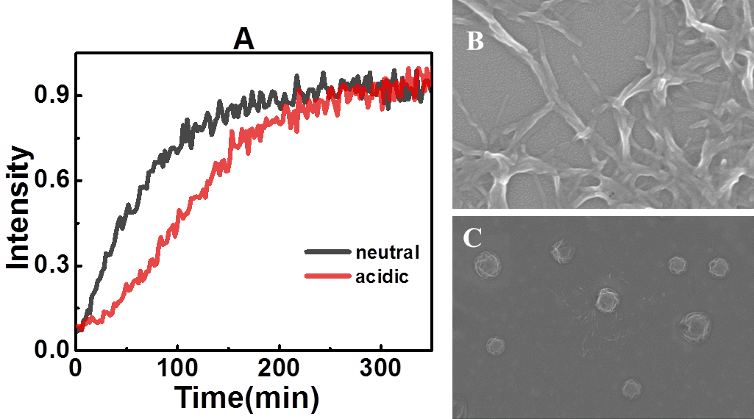

Fig. 1: (A) Time-dependent intensity change of the chiral amide I signal at neutral and acidic pH. (B and C) SEM images of hIAPP aggregates at DPPG membrane surface in neutral environment (B) and in acidic environment (C).

***P-4***

**Accurate measurement of helium-perturbed deuterium spectra for collisional studies and validation of the ab initio potential energy surfaces**

A. Nishiyama1, F. Thibault2, M. Słowiński, 1 M. Zaborowski1, N. Stolarczyk1, D.Charczun1, A. Cygan1, G. Kowzan1, S. Wójtewicz1, P. Masłowski1, R. Ciuryło1, D.Lisak1, P. Wcisło1

*1Institute of Physics, Faculty of Physics, Astronomy and Informatics,  
Nicolaus Copernicus University in Toruń, Grudziądzka 5/7, 87-100 Toruń, Poland*

*2Institut de Physique de Rennes, UMR CNRS 6251, Universié de Rennes 1,*

*Campus de Beaulieu, Bât. 11B,35042 Rennes, France*

We employ highly accurate cavity-enhanced molecular spectroscopy to study the D2-He collisions and test the D­2-He potential energy surfaces [1-5]. In this approach, the collisional effects manifest as perturbations of the shapes of the rovibrational resonances of the D­2 molecule. Using a high-finesse optical-frequency-comb-linked frequency-stabilized cavity ring-down spectroscopy technique [6], we performed a series of measurements of the helium-perturbed D2 S(2) 2-0 line at temperatures between 25 and 59*°*C and pressures between 350 and 1400 Torr.

We performed purely *ab initio* quantum scattering calculations and used them to determine the generalized spectroscopic cross sections and, subsequently, spectral line-shape parameters, including also the speed-dependence of the pressure broadening and shift coefficient as well as the Dicke narrowing parameter which were later used to simulate the speed-dependent billiard-ball profile of the He-perturbed D2 S(2) 2-0 line.

This is one of the first works in which purely *ab initio* line-shape calculations and ultra-accurate experimental results are compared.

References:

[1] J. Schaefer and W. Köhler, Physica A: Statistical Mechanics and its Applications, 1985, 129, 469–502.

[2] P. Muchnick and A. Russek, The Journal of Chemical Physics, 1994, 100, 4336–4346.

[3] A. I. Boothroyd, P. G. Martin and M. R. Peterson, The Journal of Chemical Physics, 2003, 119, 3187–3207.

[4] B. W. Bakr, D. G. A. Smith and K. Patkowski, The Journal of Chemical Physics, 2013, 139, 144305.

[5] F. Thibault, K. Patkowski, P. S. ˙Zuchowski, H. Jóźwiak, R. Ciuryło and P. Wcisło, Journal of Quantitative Spectroscopy and Radiative Transfer, 2017, 202, 308–320.  
[6] A. Cygan, S. Wójtewicz, G. Kowzan, M. Zaborowski, P. Wcisło, J. Nawrocki, P. Krehlik, Ł. Śliwczyński, M. Lipiński, P. Masłowski, R. Ciuryło, and D. Lisak, The Journal of Chemical Physics, 2016, 144, 214202.

***P-5***

**S∙∙∙F Chalcogen Bond in the 2,2,4,4-Tetrafluoro-1,3-Dithiethane-Difluoromethane complex Revealed by Microwave Spectroscopic and Theoretical Study**

Tao Lu1, Yang Zheng1, Zhining Xia1,Qian Gou 1,2, Gang Feng1,2

*1 School of Chemistry and Chemical Engineering, Chongqing University,*

*Daxuecheng South Rd. 55, 401331, Chongqing, China.*

*2 Collaborative Innovation Center for Brain Science, Chongqing University,*

*No.174 Shazhengjie, Shapingba, 400044, Chongqing, China.*

The rotational spectrum of 1:1 molecular complex of 2,2,4,4-tetrafluoro-1,3-dithiethane (C2F4S2) and difluoromethane (DFM) have been investigated using Fourier transform microwave spectroscopy with the aid of ab initio calculations. The most stable conformer of the complex has been observed experimentally. Quantum theory of atoms in molecules, [1] non-covalent interaction [2] and natural bond orbital analyses [3] demonstrate that the observed conformer are stabilized by a primary S∙∙∙F chalcogen bond together with the secondary interactions of two C-H∙∙∙O and two C-F∙∙∙F-C contacts which form a three-point F∙∙∙F∙∙∙F attractive contact interaction. Furthermore, symmetry-adapted perturbation theory analysis [4,5] indicates that electrostatic and dispersion interactions are the dominant contributors towards the stability of the complex. The skeleton structure of the complex has been accurately determined on the basis of the assignment of the rotational spectra of six isotopologues. In addition, information on the structural parameters of the non-covalent interactions and the dissociation energy of the complex has been obtained.

References:

[1] R. F. W. Bader, *Chem. Rev.* **91**, 893 (1991).

[2] E. R. Johnson, S. Keinan, P. Mori-Sanchez, J. Contreras-Garcia, A. J. Cohen, W. Yang, *J. Am. Chem. Soc.* **132**, 6498 (2010).

[3] F. Weinhold, C. R. Landis, Valency and Bonding: a Natural Bond Orbital Donor-Acceptor Perspective; Cambridge University Press: Cambridge, U.K. (2005).

[4] B. Jeziorski, R. Moszynski, K. Szalewicz, *Chem. Rev*. **94**, 1887 (1994).

[5] T. M. Parker, L. A. Burns, R. M. Parrish, A. G. Ryno, C. David Sherrill, *J. Chem. Phys.* **140**, 094106 (2014).

***P-6***

**Simulating Infrared Spectrum of *N*-MethylAcetamide Dimer by Quantum Vibration Perturbation Method**

You Li 1, Yu Zhai 1, Hui Li 1,*

1 *Laboratory of Theoretical and Computational Chemistry, Institute of Theoretical Chemistry, Jilin University, Changchun, Jilin, China*

*\* Email: prof_huili@jlu.edu.cn*

Peptide is one of the most important groups in the study of biological systems. As the simplest model to study the interpeptide interaction and the secondary structures of proteins,*N*-MethylAcetamide (NMA) dimer has been investigated extensively in both experimental and computational ways. Recently, the Quantum Vibration Perturbation (QVP) theory was developed in our group, which has shown its efficiency in simulating infrared (IR) spectra of complex systems [1-2]. In this work, we extended the QVP method to calculating the amide I vibrational resonance spectrum of two peptide groups. First, *ab initio* molecular dynamics (AIMD) simulation was performed starting from two different structures ttn and ttc due to the difficulty of interconvertion between minima configuration in the cold experimental condition. While for the quantum part, the local amide I vibrational mode of NMA monomer was adopted as vibrational coordinate. NMA’s vibrational energy levels and wave functions in Potential Optimized Discrete Variable Representation (PODVR) were calculated, and the direct products of the monomer wave functions formed the basis of this two-chromophore system. The potential energy difference between the dimer system and the sum of two isolated NMAs were regarded as perturbation term*,* varying with time in AIMD simulations. Then, we calculated instantaneous vibrational frequency shift at every time step by solving either two-dimension vibrational Schrödinger equation or degenerate perturbation theory. Finally, the semi-classical statistical mechanics was used to obtain the IR spectral line shape. The result of ttc fits well with experiment [3], with frequency red shifts being ~20cm-1 and ~40cm-1 for the two resonance spectral peaks. This work is still undergoing, and may offer a powerful tool for IR simulation of more complex systems including multiple chromophores.

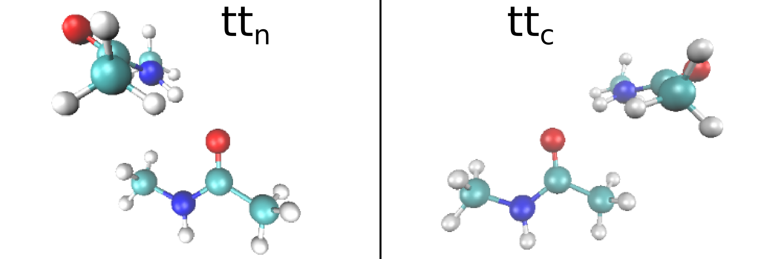

Fig.1: Two configurations of *N*-methylacetamide dimers (ttn the left and ttc the right). Red atoms are Oxygen, Blues are Nitrogen, greens are Carbon , and writes are Hydrogen.

References:

[1] Rui-Jie Xue *et al.*, *J. Chem. Theory Comput.* **13**, 191 (2017).

[2] Courtney M. Olson *et al.*, *J. Chem. Phys.* **147**, 124302 (2017).

[3] Thomas Forsting *et al.*, *Phys. Chem. Chem. Phys.* **19**, 10727 (2017)

***P-7***

**The inter- and intra-molecular potential energy surface and predicted infrared spectra for H2O-N2 dimer**

Lu Wang, Xiao-Long Zhang, and Hui Lia)

*Laboratory of Theoretical and Computational Chemistry, Institute of Theoretical Chemistry, Jilin University, 2519 Jiefang Road, Changchun 130023, People’s Republic of China*

**Abstract**

Water, as the most abundant liquid on the earth, can produce most chemical reactions with other matters. In this work, we report a first effective six-dimensional *ab initio* potential energy surface (PES) for H2O-N2 van der Waals complex, which explicitly incorporates dependence on the Q2 bending normal-mode coordinate of the H2O monomer. The electronic structure computations are carried out at the explicitly correlated coupled cluster level of theory [CCSD(T)-F12a] with an augmented correlation-consistent triple zeta basis set. Then, a new five-dimensional intermolecular PES is obtained by non-linear-least-squares fit of 40890 points to the Morse/long-range potential function form. This fit has the root-mean-square (RMS) deviation of 0.98 cm-1 for the interaction energy less than 2000.0 cm-1. The infrared spectra for H2O-N2 dimer is predicted for the first time based on the resulting vibrationally averaged PES and the results are in good agreement with the experimental values.

***P-8***

**Influence of alkyl side-chain structure on charge transfer rate**

Chuanzhao Li1, Yi Luo1, Shuji Ye*1

1Hefei National Laboratory for Physical Sciences at the Microscale, and Synergetic Innovation Center of Quantum Information & Quantum Physics, University of Science and Technology of China, Hefei, 230026, China.

Organic-inorganic perovskite solar cells (PSCs) based on organic hole transport materials (HTMs) have garnered considerate attention owning to their excellent advantages such as low-cost, easy tunability and solution-processable attributes. An emergent question is how to regulate the charge transfer rate between provskite and HTMs because it is an important factor that affects the overall device performance. Herein, we report the first investigation into the correlation between alkyl side-chain structure and charge transfer rate in a series of P3ATs by applying sum frequency generation vibrational spectroscopy (SFG) and time-resolved photoluminescence (TRPL). Our results show that charge transfer rate decrease as the order of alkyl side-chain decreases. Most importantly, we further find that the order of alkyl side-chain can be as an optical marker for its steric hindrance on the Π-Πstacking distance. So this work can provide a key strategy to design high performance device by improving the order of alkyl side-chain.



References:

[1] Z. Ma, H. Geng, D. Wang, Z. Shuai, *J. Mater. Chem. C*  **4**, 4546(2016).

[2] Xiao, M.; Joglekar, S.; Zhang, X.; Jasensky, J.; Ma, J.; Cui, Q.; Guo, L. J.; Chen, Z. J. Am. Chem. Soc. **139**, 3378−3386(2017).

***P-9***

**A systematic search for the best functionals to describe disulfide bond**

Hexu Ye , Malgorzata Biczysko

*Shanghai University, 99 Shangda Lu, Shanghai 200444, China*

The disulfide bonds, including covalent disulfide bond (S–S) and weak electrostatic interactions (S···S) are important structural features in organic chemistry and, more particularly, in protein chemistry. Despite being weaker than the C–C bond, the disulfide bond is important in the folding and stability of many biomolecules by forming structural links between the different parts of a molecule. As a consequence, the effect of substitution of oxygen by sulfur on many properties is of particular relevance in biochemistry and chemical reactivity. Therefore, the investigation of the changes occurring in structural, chemical-physical and spectroscopic properties upon such substitution is of much general interest. As density functional theory (DFT) is increasingly applied to not only covalent interactions but also weak interactions, we are wondering how well disulfide bonds are described by different DFT models. Therefore, 7 density-functional-based methods with and without dispersion corrections were tested. By including different dispersion corrections, 10 different combinations of functionals and dispersion corrections were investigated. All methods have been considered together with the maug-cc-pVTZ basis set. Four double hybrid functionals, which include a fraction of MP2 correlation were considered: B2PLYP, DSDPBEP86, PBE0DH, PBEQIDH. Moreover we have considered the still popular Becke three-parameter hybrid functionals, B3LYP. Truhlar group has published a number of functionals that have been fitted to include weak interactions, and they behave differently to most other functionals. Two of them are considerde: M06-2X, MN15. Finally Grimme’s dispersion corrections, D3 (together with reccomended Becke-Johnson dumping) was included for: B2PLYP-D3, B3LYP-D3, M06-2X-D3. The assignment of the rotational spectra for the molecular systems with two kinds of disulfide bond (S–S/S···S)[1-3], provided detailed structural information for the sulfur-sulfur bridge and a reference for the following research.

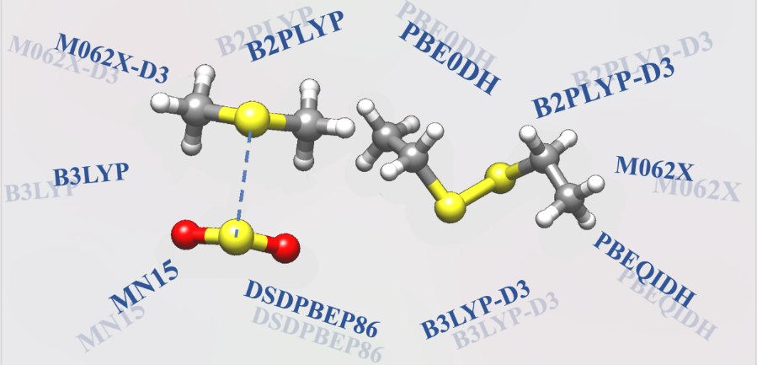

References:

[1] J. Demaison, N. Vogt, R T. Saragi, M. Juanes, A. Lesarri, *ChemPhysChem*. **20**, 366 (2018)

[2] D A. Obenchain, L. Spada, S. Alessandrini, S. Rampino, S. Herbers, et al, *Angew. Chem., Int. Ed.* **57**, 15822 (2018)

[3] J. Zhang, X. Li, Q. Gou, G. Feng, *J. Phys. Chem. A*, **122**, 5597 (2018)

***P-10***

**Simulation of fully anharmonic IR spectra for flexible peptides.**

Ruiqin Xu1, Malgorzata Biczysko1, Bin Yan2, Sjors Bakels2, Robbert C. Ouwersloot2, Dennis W. P. M. Löwik2 and Anouk M. Rijs2

*1Shanghai University, 99 Shangda Lu, Shanghai 200444, China*

*2Radboud University Nijmegen, FELIX Laboratory, The Netherlands.*

The conformational preference of the capped tripeptide EAR (Glu-Ala-Arg-NH2) is complicated due to the high flexibility and presence of several weak interactions. Among the various types of investigations spectroscopies are the most powerful tools, allowing direct detection of different binding schemes and three-dimensional (3D) conformation via microwave (MW) measurements or indirect analysis through finger-print vibrational features in infrared (IR), Raman, Resonance Raman, UV-vis or fluorescence spectra, including also their chiral counterparts. These sophisticated experiments call for accurate and reliable theoretical support in order to link the rich experimental data to the desired information on the structure and properties of complex molecular systems. In this work the structural assignment of EAR was performed via the comparison between the calculated fully anharmonic spectra with the experimental one, in the NH stretching region (3150-3700 cm-1). The latter was acquired by employing IR-UV ion dip spectroscopy under laser-desorbed jet cooling conditions. The conformational search include three different families depending on the form of the Arginine side chain: two non-zwitterionic types (canonical and tautomeric structures) and one zwitterionic type with a deprotonated Glu and protonated Arg side chain (abbreviated as Z). Their relative energies were determined by single point energy computations at the B2PLYP-D3/maug-cc-pVTZ level of theory, and for the close-lying most stable structures (Z1 and Z2) followed by fully anharmonic B3LYP-D3/6-31G(d) GVPT2 computations, employing also the reduced dimensionality schemes. The computed spectrum of the lowest energy conformer Z1 shows many more features, some due to the non-fundamental transitions, in good agreement with the experimental results. Improved accuracy is obtained by the hybrid scheme, with harmonic wavenumbers corrected at the higher level of theory.

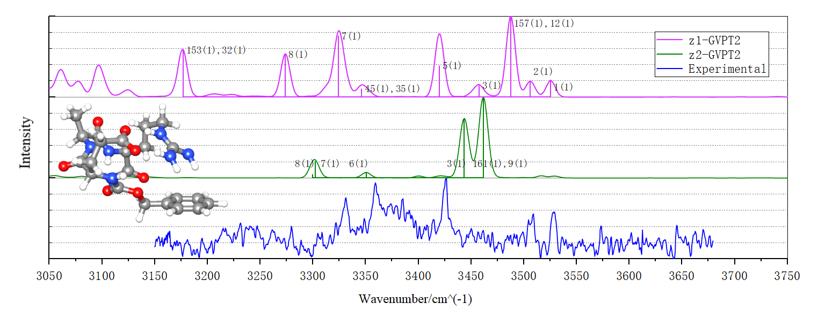

Fig. 1: Experimental spectrum of Glu-Ala-Arg-NH2 compared to the GVPT2 computations for the two lowest energy conformers.

Reference

[1] J. Bloino, A. Baiardi, M. Biczysko*, Int. J. Quantum Chem*. **116**, 1543 (2016)

[2] M. Biczysko, J. Bloino, C. Puzzarini, *WIREs Comput Mol Sci* **8**, e1349. (2018)

[3] A. M. Rijs, J. Oomens, J., Eds. Gas-Phase IR Spectroscopy and Structure of BiologicalMolecules; Topics in Current Chemistry; Springer International Publishing, 2015; Vol. 364

***P-11***

**Two new electronic transitions [21.2]0+** – ***X*0+ and**

**[22.2]0+** – ***X*0+ of tungsten oxide (WO)**

Jicai Zhang1,2, Dongmei Zhao1, Xinwen Ma1, Jie Yang1

*1Institute of Modern Physics, Chinese Academy of Sciences, Lanzhou 730000, China*

*2**University**of**Chinese**Academy**of**Sciences**, Beijing 100049, China*

Combing pulsed discharge supersonic beam and laser ablation techniques, we investigated the laser-induced fluorescence (LIF) excitation spectra of jet-cooled WO molecule in the range of 21000 – 23200 cm-1. Fig.1 (a) shows our experimental setup, the gas phase WO molecules were produced by the reaction to O2 molecules with the tungsten atoms ablated from a pure tungsten target. In this study, ten electronic transition bands were observed for the first time and assigned to the two electronic transitions [21.2]0+ – *X*0+ and [22.2]0+ – *X*0+. The rotational constants of these two excited electronic states have been derived by rotational analysis of the spectra. Fig.1 (b) shows the experimental and simulated spectra of [21.2]0+ – *X*0+ (0 – 0) transition, the tungsten isotope splitting was clearly resolved in P-branch, which caused by four major tungsten isotopes, 28.6% 186W, 30.7% 184W, 14.28% 183W, and 26.3% 182W. Based on the vibrational frequencies in the ground electronic state X0+ and upper [21.2]0+ state, a blue isotopic shift ~0.03cm-1/amu is expected in calculation. Nevertheless, a red isotopic shifts ~0.19 cm-1/amu is observed experimentally. By analysis of the spectra reveals that the abnormal isotopic shifts are due to the strong interstate perturbations between different vibronic states, which was very similar with the observed result of A state by Ram *et al.* [1]. In addition, the lifetimes of the observed vibronic states were measured as show in Fig.1 (c), which are approximately in the same scale of 500 ns (360 – 600 ns) for different vibrational levels of the [21.2]0+ and [22.2]0+ states. The short lifetimes illustrate that different vibronic bands might have the same spin multiplicity as the ground state and they are not interacted or not strongly interacted with the different multiplicities states.

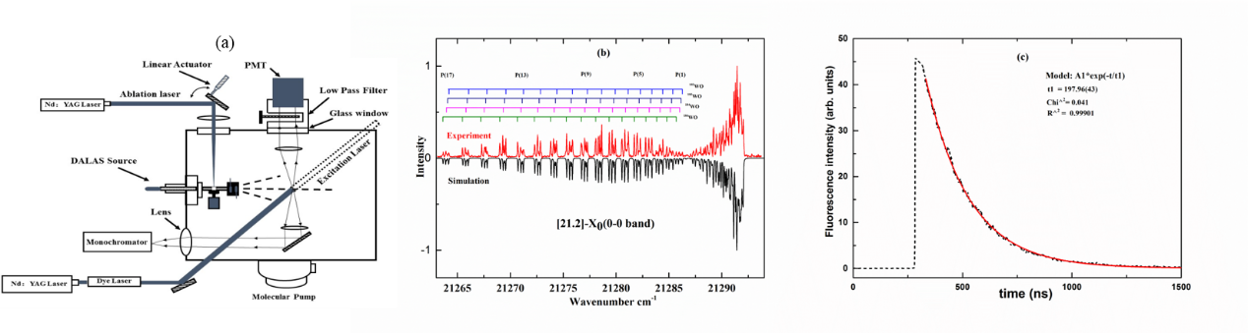Fig. 1: (a) Schematic diagram of the experimental setup. (b) The Rotationally resolved LIF excitation spectra of the [21.2]0+ – X0+ (0 – 0) band of WO. (c) A typical fluorescence decay trace of the [22.2]0+ – *X*0+ (1 – 0) band, the dotted line is the experimental result and red line is an exponential fit of the fluorescence decay.

References:

[1] R. S. Ram, J. Liévin b, Peter F. Bernath, J. Mol. Spectrosc. 256, 216 –227 (2009)

***P-12***

**Vibronic spectra of jet-cooled 2-cyanoindole and its water clusters their and computational calculations**

Hak Seung Ryu, Cheol Joo Moon, Ahreum Min, Woo Yeong Kim, Myong Yong Choi

*Department of Chemistry (BK21+) & Research Institute of Natural Science,*

*Gyeongsang National University, Jinju 52828, Republic of Korea*

In this study, the excitation spectra of 2-cyanoindole (2CI) and its water clusters, 2CI-(H2O)n (n = 1~3), have been measured by using mass-selected resonant two-photon ionization (R2PI) in the gas phase. A broad spectral feature of the R2PI spectrum of 2CI was obtained; while sharp spectral R2PI spectra of 2CI-(H2O)1-3 clusters were observed.The origin band of each cluster shifted to the red frequency as the number of water increased. The transition energy of the origin band of the R2PI spectrum was compared with that obtained by density functional theory calculations.[1] To further investigate the 2CI-(H2O)0-3 systems, we have employed the various gas-phase spectroscopic techniques, such as UV-UV hole burning (UV-UV HB) and IR-dip spectroscopy.[2]

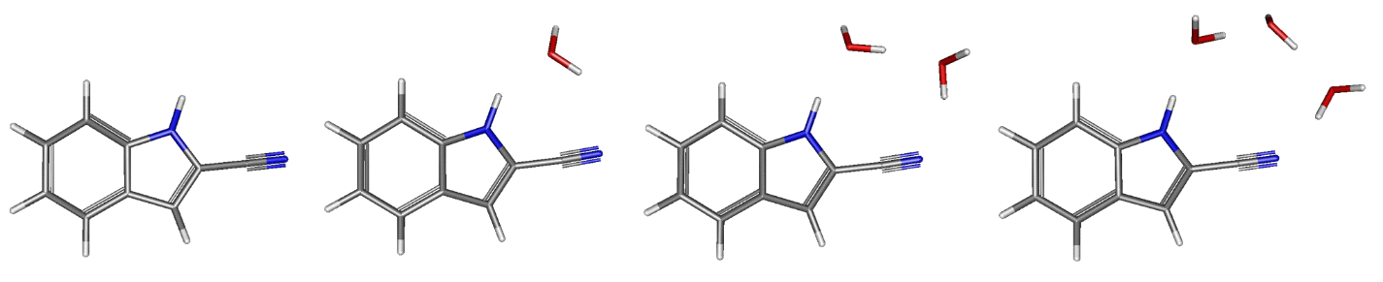

Fig. 1: Optimized structures of 2CI-(H2O)0-3 in the ground state (S0) calculated at the B3LYP/ 6-311++G(d,p) level of theory.

References:

[1] A. R. Ahn, A. R. Min, C. J. Moon, J. H. Lee, M. Y. Choi, *Chemi. Physi. Lett.,* **616-617**, 55-60 (2014).

[2] A. R. Min, A. R. Ahn, C. J. Moon, J. H. Lee, M. Y. Choi, S. K. Kim, *Chemi. Physi. Lett.,* **614**, 263-268 (2014).

***P-13***

**Photodissociation dynamics of the N2O+ cation via B2Π state**

Zhengfang Zhou, Hao Liang, Shaowen Feng, Yang Chen, Dongfeng Zhao

*CAS Center for Excellence in Quantum Information and Quantum Physics, Hefei National Laboratory for Physical Sciences at the Microscale, Department of Chemical Physics, University of Science and Technology of China, Hefei, Anhui 230026, PR China.*

Photodissociation dynamics of the N2O+ cation has been experimentally investigated using the recently developed cryogenic cylindrical ion trap velocity map imaging spectrometer. N2O+ cations are produced from an electron impact ionization ion source and are internally cooled down in a cryogenic ion trap via collisions with the cold helium buffer gas. After extraction from the ion trap, the cold N2O+ cations intersect with a loosely focused unltraviolet laser beam for photodissociation. We select three photolysis wavelengths (254.001nm, 252.593nm, 247.576nm) where the ultraviolet photon energies locates in the low energy region of B2Π state as photolysis laser. Total kinetic energy release (TKER) spectra, as well as recoiling angle distribution of the photofragmented NO+(1Σ+) have been measured using the DC-Slice velocity map imaging technique. All images show anisotropic spatial distributions, indicating that the dissociation proceeds by absorbing one UV photon via the second excited state B2Π of N2O+. Two dissociation channels, leading to the production of NO+(1Σ+) + N(1D) (channel 1 ) and NO+(1Σ+) + N(2P) (channel 2 ), respectively, have been interpreted from the present result. Specifically, the NO+(1Σ+) + N(2P) channel are found to open at ~ 254.001 nm, which is in good agreement with the previously reported dissociation energy for this channel and the large positive of the anisotropy parameter indicating that it was direct dissociation of B2Π state.

***P-14***

# Spectroscopic Detection of Elusive Oxyphosphinidene

Xianxu Chu , Xiaoqing Zeng*

College of Chemistry, Chemical Engineering and Materials Science, Soochow University, Suzhou, China.

E-maile: xqzeng@suda.edu.cn

Low-valent phosphorus compounds, such as phosphinidene R-P and phosphinidene oxides R-P=O, are highly reactive. Such transient species are difficult to study in traditional ways. Very recently, aryl phosphinidenes[1] have been detected by matrix-isolation spectroscopy. Although, microwave spectroscopy has been applied for structural characterization of H-PO, the spectroscopy, structure, and reactivity of other phosphinidene oxides (R-PO), the key intermediates in the oxidation of phosphines and decomposition of flame-retardant phosphonates, remain barely explored. Herein, we report the first-time detection and observation of its isomerization with methoxyphosphinidene (Me-OP).[2] Furthermore, the oxygen scrambling process during the oxygenation of prototypic phosphinidene oxide (FPO)[3] has also been observed by means of cryogenic matrix-isolation infrared spectroscopy.



Fig. 1: (A) IR spectrum of Ne-matrix isolated MeOP(N 3 ) 2 . (B) IR spectrum of the Ne-matrix isolated laser photolysis (266 nm, 95 min) products of MeOP(N 3 ) 2 . (C) IR difference spectrum reflecting the change of the Ne-matrix upon a 193 nm laser irradiation (6 min). The IR bands of HN3 (a), CH3OP(N3)2 (b), CH3OP (c), CH3PO (d) are labeled.

References:

[1] (a) A. V. Akimov; Y. S. Ganushevich; D. V. Korchagin; V. A. Miluykov; E. Y. Misochko *Angew. Chem., Int. Ed*. **2017**, *56*, 7944−7947. (b) A. Mardyukov; D. Niedek and P. R. Schreiner, *J. Am. Chem. Soc.* **2017**, *139*, 5019−5022.

[2] X. X. Chu, Y. Yang, B. Lu, Z. Wu, W. Y. Qian, C. Song, X. F. Xu, M. Abe and X. Q. Zeng, *J. Am. Chem. Soc.*, **2018**, *140*, 13604–13608.

[3] X. X. Chu, C. Song, Y. Yang and X. Q. Zeng. *Chem. Commun.***2019**, 55, 245-248.

***P-15***

**Structure and Excited-state Dynamics of Corannulene**

*Ayumi Kanaoaka1, Masaaki Baba1, Masatoshi Misono2, Masashi Tsuge3, Pavithraa Sundararajan4, and Yuan-Pern Lee4*

*1Kyoto University, Japan, 2Fukuoka University, Japan, 3Hokkaido University, Japan, 4National Chiao Tung University, Taiwan*

Corannulene (**C5V**) is one of the prototypical molecules of **Bucky bowl**, which is a polyaromatic hydrocarbon (PAH) with nonplanar π conjugate system. It is composed of one five-membered ring and five six-membered rings and molds its unique character which is derived from out-of-plane vibration like bowl-to-bowl inversion. We analyzed the vibronic bands of S1-S0 transition in a supersonic jet and investigated structure and excited-state dynamics. The S1 state was assgined to 1E2.We also analyzed the infrared bands of corannulene in solid para-H2. Two protonated molecules H+C20H10 were confirmed by electron bombardment during deposition of a mixture. Some resemblance is attained for the observed infrared spectrum and UIR intersteller emission bands.

***P-16***

**Theoretical investigations of rate coefficients of the H + H2O2 two-channel reaction on a full-dimensional potential energy surface**

Xiaoxiao Lu1,2, Xing-an Wang1, Bina Fu2, Donghui Zhang2

*1Department of Chemical Physics, University of Science and Technology of China, Jinzhai Road 96, Hefei, 230026, China*

*2State Key Laboratory of Molecular Reaction Dynamics and Center for Theoretical and Computational Chemistry, Dalian Institute of Chemical Physics, Chinese Academy of Sciences, Zhongshan Road 457, Dalian, 116023, China*

Here we reported the rate coefficients of the H + H2O2 reaction, covering both the H2 +HO2 and OH + H2O product channels. The current results are calculated using the ring polymer molecular dynamics (RPMD), quasi-classical trajectory (QCT), and canonical variational transition state theory (CVT) with the small curvature tunneling (SCT) correction at 200 K ≤ T ≤ 1000 K, in conjunction with the recently published fundamental invariant-neural network (FI-NN) potential energy surface (PES) [1]. Given that the previous experimental values vary widely, especially at low temperatures, the present RPMD rate coefficients show excellent agreement with most of the experimental values [2]. Furthermore, the current QCT and CVT/SCT calculations also predict good results at some temperatures. These results demonstrate the good applications of the current dynamics to polyatomic chemical reactions and the accuracy of the full-dimensional FI-NN PES.

References:

[1] X. Lu, K. Shao, B. Fu, X. Wang, and D. H. Zhang, *Phys. Chem. Chem. Phys.* **20**, 23095 (2018).

[2] X. Lu, Q. Meng, B. Fu, X. Wang, and D. H. Zhang, *J. Chem. Phys.* **149**, 174303 (2018).

***P-17***

**Molecular Spectroscopy with kHz Accuracy in the Mid-Infrared**

Z.-T. Zhang, C.-F. Cheng, Y. R. Sun, A.-W. Liu, S.-M. Hu

*Hefei National Laboratory for Physical Science at Microscale,*

*University of Science and Technology of China, Hefei, China*

Precision spectroscopy of molecules in the mid-infrared region where the fundamental bands are located is of great interest in fundamental physics. Mid-infrared lasers with narrow linewidth and long-term stability are needed. In this presentation we report a new method to reduce the linewidth of a continuous-wave optical parametric oscillator (OPO) by locking the near-infrared pump and signal lights to an optical frequency comb, which also results in a long-term stability of the mid-infrared idler laser. Combined with high sensitive multi-pass cell or cavity-enhanced absorption technique, it allows to measure weak transitions of molecules with an accuracy of a few kHz.

***P-18***

**Cavity-Assisted Velocity-selected Optical Double-resonance Spectroscopy (CAVODS) of molecules with continuous-wave laser**s

C.-L. Hu, A.-W. Liu, C.-F. Cheng, T.-P. Hua, Y. R. Sun, Y. Tan, J. Wang, S.-M. Hu∗

Hefei National Laboratory for Physical Sciences at Microscale, iChem center, University of Science and Technology of China, Hefei, 230026 China;

Double resonance spectroscopy was frequently used in study of dynamics and molecular spectroscopy, due to its highly selectivity of transitions. Optical resonant cavities can be used to enhance the effective absorption path length, and the laser power inside the cavity as well to saturate very weak ro-vibrational transitions of molecules. We combined double resonant absorption with cavity ring-down spectroscopy and got a high precision transition frequency of carbon monoxide molecule. The energy difference between the J = 9 levels in the ground and V = 6 states of CO was measured through double resonance using the (J = 10, V = 3) level as the intermediate level, and was determined to be 375 371 090 939.3kHz ±2 kHz (δν / ν = 4 × 10−12).

***P-19***

**Lamb-dip Measurement of the Overtone Transition of HD at 1.39 μm**

T.-P. Hua, J. Wang, Y. R. Sun, A.-W. Liu, S.-M. Hu

*Hefei National Laboratory for Physical Sciences at Microscale, CAS Center for Excellence in Quantum Information and Quantum Physics,*

*University of Science and Technology of China, Hefei, 230026 China*

**Abstract**

HD is one of the simplest molecular whose energy levels can be calculated based on quantum electrodynamics (QED) and a few fundamental physical constants. Precision spectroscopy of HD is a test ground of the molecular theory and QED by comparing theoretical energy levels and experimental data. Frequencies of ro-vibrational transitions of HD could be also used to determine the proton-to-electron mass ratio. The R(1) line in the $ν=2-0$ band of HD was measured by CRDS and NICE-OHMS from two different groups, with stated accuracies of 85kHz and 20kHz, respectively. However, there is a deviation of 0.9MHz between the two results. We present here our recent experimental result of this transition of HD by three different methods, CRDS, CEAS, and NICE-OHMS. We have improved the S/N ratio by a factor of 20, and revealed that the Lamb dip of the HD R(1) transition has a line profile significantly different from that of conventional molecular lines.

References:

[1] Shelkovnikov. A, Butcher. R. J, Chardonnet. C, Amy-Klein. A, “Stability of the Proton-to-Electron Mass Ratio,” Phys. Rev. Lett*.* 100**,** 150801 (2008).

[2] L.-G. Tao, A.-W. Liu, K. Pachucki, J. Komasa, Y. R. Sun, J. Wang, and S.-M. Hu, “Toward a determination of the proton-electron mass ratio from the lamb-dip measurement of HD,” Phys. Rev. Lett. **120**, 153001 (2018).

[3] F. M. J. Cozijn, P. Dupré, E. J. Salumbides, K. S. E. Eikema, and W. Ubachs, “Sub-doppler frequency metrology in HD for tests of fundamental physics,” Phys. Rev. Lett. **120**, 153002 (2018).

***P-20***

**Measurement of Absolute 12C16O2 Transition Frequencies in (30013)-(00001) Band**

H. Wu, C.-L. Hu, Y. R. Sun, A.-W. Liu, S.-M. Hu

*Hefei National Laboratory for Physical Science at Microscale,*

*University of Science and Technology of China, Hefei, China*

Carbon dioxide (CO2) is one of the most important species among the Earth’s atmosphere, which has been known to be a strong greenhouse forcing agent. The linear triatomic structure of CO2 gives strong spectroscopic transitions in IR region, which can serve as a benchmark for spectroscopic measurements. In this case, high precision measurement of absolute transition frequency of spectroscopic transitions is needed.

Focus on the (30013)-(00001) band of 12C16O2 near 1.6 $μm$, optical frequency comb locked cavity ring-down spectroscopy based saturated absorption spectroscopy technique[1] is applied in our work. Absolute transition frequency of 72 lines from P(70) to R(72) with uncertainty from 0.7 to 29 kHz has been measured. Importantly, transitions with rotational quantum number up to 72 (line intensity 6.4×10-27 cm/molecule) is measured with S/N ratio up to 4. This result can help to improve the upper level spectroscopic constants for more accuracy calculation.

References:

[1] L.-G. Tao, T.-P. Hua, Y. R. Sun, J. Wang, A.-W. Liu, and S.-M. Hu*, *Journal of Quantitative Spectroscopy and Radiative Transfer*, 210: 111-115 (2018).

***P-21***

**Near infrared-to-near ultraviolet triplet-triplet annihilation upconversion by strong spin-forbidden transition**

Min zheng1, Yaxiong Wei1, Xiaoguo Zhou,1,2* Shilin Liu1,2

*1Hefei National Laboratory for Physical Sciences at Microscale, iChEM (Collaborative Innovation Center of Chemistry for Energy Materials), Hefei, Anhui 230026, China*

*2Department of Chemical Physics, University of Science and Technology of China, Hefei, Anhui 230026, China*

Three new singlet-triplet transient Os(II) complexes were designed and synthesized for triplet- triplet annihilation (TTA) upconversion with DPA, Perylene and BPEA as acceptor. These complex ligands were carefully selected, in order to obtain much longer triplet lifetime and accurately adjust the triplet energy level of photosensitizers. Triplet state lifetime was determined to be 107 ns for Os-dipy, 373 ns for Os-phen and 386 ns for Os-diphen by nanosecond transient absorption spectra. Steady-state phosphorescence emission spectra indicates the triplet energy level is 1.75 eV for Os-dipy, 1.80 eV for Os-phen and 1.74 eV for Os-diphen, and matched well with the acceptor DPA of 1.75 eV. Strongly upconversion fluorescence was observed from near-infrared to near-ultraviolet, blue and green light and the largest anti-stokes is up to 1.14 eV with the quantum yield as high as 5.9 % in deaerated dichloroethane.



Fig1.TTA upconversion of Os(II) complexes as photosensitizer with DPA, Perylene and BPEA as acceptor

References:

[1] Wei Y, Zheng M, Zhou Q, et al. *Org. Biomol. Chem.* **16**: 5598(2018).

[2] Zhou Q, Zhou M, Wei Y, et al. *Phys. Chem. Chem. Phys.* **19**: 1516(2017).

[3] Wei Y, Zhou M, Zhou Q, et al. *Phys. Chem. Chem. Phys*. **19**: 22049(2017)

***P-22***

**Double-edged effect of Al(III) ions on amyloid fibrillation of hen egg white lysozyme revealed by Raman spectroscopy**

Lei Xing1 , Ning Chen2 , Wei Fan2, Mengna Li2 , Xiaoguo Zhou1,2*, Shilin Liu1,2*

*1Hefei National Laboratory for Physical Sciences at Microscale, iChEM (Collaborative Innovation Center of Chemistry for Energy Materials), Hefei, Anhui 230026, China*

*2Department of Chemical Physics, University of Science and Technology of China, Hefei, Anhui 230026, China*

Protein fibrillation is a hallmark of neurodegenerative disease, like Alzheimer's disease. The influence of the Al(III) ions on amyloid fibrillation is significant to understand the relationship between the metal ions and Alzheimer's disease. Raman spectroscopy were applied to investigate the amyloid formation of hen egg white lysozyme under thermal incubation with the presence of Al(III) ions or acids, combined with atomic force microscope (AFM) imaging and Thioflavin T (ThT) fluorescence measurements. The kinetics of the lysozyme conformational change were measured by monitoring six characteristic spectral markers. The band of the Phe amino residue in side chains at 1003 cm-1, and the two Trp residue peaks at 759 cm-1 and 1340−1360 cm-1 correlated to the tertiary structure, whereas, the two N-Cα-C stretching vibrations at 899 cm-1 and 935 cm-1, and the amide I band (at 1640−1680 cm-1) were associated with the lysozyme skeleton. Based on the results, a four-stage transformation mechanism is proposed for the kinetics of lysozyme amyloid fibrillation under thermal/Al(III) treatment. By comparing the different kinetics with the thermal/Al(III) and thermal/acid treatments, the double-edged role of the Al(III) ions on amyloid fibrillation of lysozyme is revealed: the Al(III) ions are the stabilizers to postpone the destruction of α-helix, but they accelerate the conformational transformation from the α-helix to the organized β-sheets with skipping random coils. The present investigation sheds light on the controversial influence of the Al(III) ions on amyloid fibrillation of lysozyme.

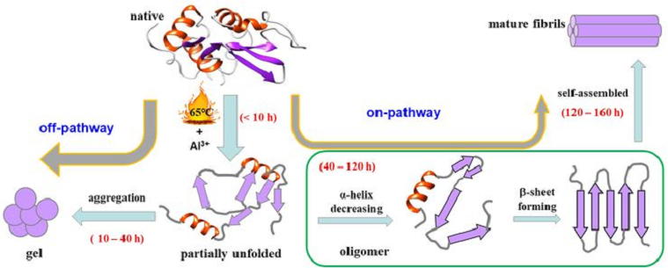

Fig 1. Four-stage mechanism of lysozyme amyloid fibrillation in the thermal solution with the presence of the Al(III) ions

References:

[1] L. Xing, W. Fan, N. Chen, M. Li, X. Zhou, and S. Liu, *J. Raman Spectrosc.* 1-12(2019).

[2] L. Xing, K. Lin, X. Zhou, S. Liu, and Y. Luo, *J. Phys. Chem. B* **120**, 10660(2016).

[3] K. Lin, X. Zhou, Y. Luo, and S. Liu, *J. Phys. Chem. B* **114**, 3567(2010).

***P-23***

**Pyrolysis of Methylal Revealed by Imaging Photoelectron Photoion Coincidence Spectroscopy**

Tongpo Yu 1, Patrick Hemberger2, Xiaoguo Zhou1* , Shilin Liu1*，Andras Bodi2*

*1.Hefei National Laboratory for Physical Sciences at the Microscale, iChEM (Collaborative Innovation Center of Chemistry for Energy Materials), Department of Chemical Physics, University of Science and Technology of China, Hefei 230026,*

*China.*

*2.Laboratory for Femtochemistry and Synchrotron Radiation, Paul Scherrer Institute, Villigen 5232, Switzerland.*

The unimolecular dissociation reactions of energy-selected methylal cations have been studied by imaging photoelectron photoion coincidence spectroscopy at the vacuum-ultraviolet (VUV) beamline of the Swiss Light Source. In the photon energy range of 9.5−13.9 eV, methylal ions decay by numerous fragmentation channels. Modeling the breakdown diagram yielded The 0 K appearance energy of m/z=45 and m/z=45 was determined to be E0(C2H5O) = 10.23 ± 0.010 eV and E0(CH3O2) = 12.87 eV fragment ions, respectively, formed by sequential dissociation channels. Quantum chemical calculations and experimental results confirmed a fast conversion to the A′ state and that the rate-determining step is a tight transition state on the potential energy surface. Appearance energies were also derived for the sequential dissociation products from the methylal cation, Statistical rate theory modeling of the breakdown diagram can also be used to predict the fractional ion abundances and thermal shifts in mass spectrometric pyrolysis studies to help assigning the m/z channels either to ionization of the neutrals or to dissociative ionization processes, with potential use for combustion diagnostics.

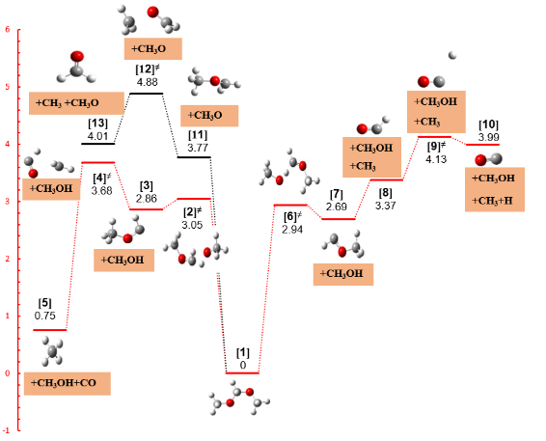

Figure 1. Fragmentation pathways and potential energy surface of the methylal ion at the CBS-QB3 level of theory. The energies are given in electronvolts and are relative to the neutral methylal. red lines show minor reaction channels.

References:

[1] Heringa, M. F. Slowik, J. G. Prevot, A. S. Baltensperger, U.Hemberger, P. Bodi, *A.J Phys Chem A* ***120****:3397(2016).*

[2] Liang, S. Hemberger, P. Neisius, N. M. Bodi, A. Grutzmacher, H. Levalois-Grutzmacher, J. Gaan, S. *Chemistry* ***21****: 1073(2015)*

***P-24***

**The A2Пu - X2Пg electronic transition of Br2+**

Hao Liang, Zhenfang Zhou, Yang Chen*, and Dongfeng Zhao*

*CAS Center for Excellence in Quantum Information and Quantum Physics, Hefei National Laboratory for Physical Sciences at the Microscale, and Department of Chemical Physics, University of Science and Technology of China, Hefei, Anhui, 230026, P.R. China.*

Abstract

The A2Пu - X2Пg electronic transition of Br2+ has been studied in the 500 – 720 nm wavelength range using the cryogenic cylindrical ion trap velocity map imaging spectrometer. Br2+ cations are produced in an electron impact ionization source, mass selected, and trapped in a cryogenic cylindrical ion trap to cool down both rotational and vibrational temperature. Vibrationally resolved photofragment excitation spectra are recorded by [1+1] photodissociation via A2Пu intermediate state. The ground-state spin-orbit assignments of the observed bands are identified by measuring total kinetic energy release (TKER) spectra of photofragment products at different wavelengths using the velocity map imaging technique. Photofragment excitation spectra for all three isotopologues of Br2+ (79Br2+,79Br81Br+,81Br2+) are recorded, which yields the vibrational assignments of the observed bands. The present results has allowed to make a full vibrational assignment of the A2Пu - X2Пg electronic transition of Br2+.

***P-25***

**A Cryogenic Cylindrical Ion Trap Velocity Map Imaging Spectrometer**

Zefeng Hua, Yang Chen**＊**, and Dongfeng Zhao**＊**

*CAS Center for Excellence in Quantum Information and Quantum Physics, Hefei National Laboratory for Physical Sciences at the Microscale, and Department of Chemical Physics, University of Science and Technology of China, Hefei, Anhui, 230026, P.R. China.*

A cryogenic cylindrical ion trap velocity map imaging spectrometer (CIT-VMI) has been developed to study photodissociation spectroscopy and dynamics of gaseous molecular ions and ionic complexes. A cylindrical ion trap (CIT) made of oxygen-free copper is cryogenically cooled down to ~7 K by a closed cycle helium refrigerator and is coupled to a velocity map imaging (VMI) spectrometer. The cold trap is used to cool down the internal temperature of mass selected ions, and to reduce the velocity spread of ions after extraction from the trap. For CO2+ ions, a rotational temperature of ~12 K is estimated from the recorded [1+1] two-photon dissociation spectrum, and populations in spin-orbit excited X2Πg,1/2 and vibrationally excited states of CO2+ are found to be non-detectable, indicating an efficient internal cooling of the trapped ions. Based on the time-of-flight peak profile and the image of N3+, the velocity spread of the ions extracted from the trap, both radially and axially, is interpreted as approximately ±25 m/s. Experimental image of fragmented Ar+ from 307 nm photodissociation of Ar2+ shows that, benefitting from the well-confined velocity spread of the cold Ar2+ ions, a VMI resolution of Δv/v ~ 2.2% has been obtained. The current instrument resolution is mainly limited by the residual radial speed spread of the parent ions after extraction from the trap.

***P-26***

**Velocity map imaging study on the singlet and triplet dissociation pathway of OCS near 230 nm**

Xiangkun Wu1, Zhi Gao1, Xiaoguo Zhou1,2*, ShiLin Liu1,2*

*1Hefei National Laboratory for Physical Sciences at Microscale, iChEM (Collaborative Innovation Center of Chemistry for Energy Materials), Hefei, Anhui 230026, China*

2Department of Chemical Physics, University of Science and Technology of China, Hefei, Anhui 230026, China

Carbonyl sulfide (OCS) is an important component of the Earth's atmosphere and is the highest sulfur compound in the atmosphere and playing an important role in the Earth's S cycle. In this experiment OCS was photoexcited by a photon at 230 nm, and dissociated to the vibrationally cold but rotationally hot CO (X1Σg+,v=0, J=42~69) fragment, which was ionized by the resonance enhanced multiphoton ionization. Through detecting the time-sliced velocity map images of CO+ in various rotational states (J=55~69), the kinetic energy release distribution and angular distribution of the CO fragment were obtained, in which both the singlet dissociation channel of S(1D) + CO and the triplet pathway of S(3PJ) + CO were involved. For the triplet fragment channel, the total quantum yield of OCS dissociation at 230 nm was estimated to be 4.16% based on the measured branching radio at every rotational state. With the aid of the high-level quantum chemical calculation of potential energy surface and the absorption cross sections of OCS,[1] the dissociation mechanism of along the triplet channel of OCS with photolysis at 230 nm was stated. The ground state OCS (X1A') was is photoexcited to the bent A1A' state by photoabsorption at 230 nm, then decayed decays back to a bent X1A' in a bent structure via internal conversion, and subsequently coupleds to the 23A"(c3A") state by spin-orbit coupling followed by a direct dissociation along its potential energy surface.

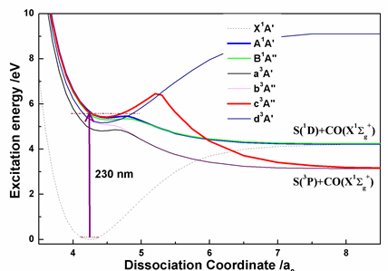

Fig. 1: The potential energy surface of OCS along R(C-S)

References:

[1] Schmidt, J. A.; Johnson, M. S.; McBane, G. C.; Schinke, R, J. Chem. Phys. **136**, 131101 (2012).***P-27***

**High precision rotational constants of 12C16O determined**

**by ro-vibrational transitions**

Jin Wang, Changle Hu, Yu Robert Sun, Anwen Liu,*, Shuiming Hu

Hefei National Laboratory for Physical Sciences at Microscale, iChem center, University of Science and Technology of China, Hefei, 230026 China;

CAS Center for Excellence in Quantum Information and Quantum Physics,

University of Science and Technology of China, Hefei, 230026 China;

Email: [jinwang@ustc.edu.cn](mailto:jinwang@ustc.edu.cn), [awliu@ustc.edu.cn](mailto:awliu@ustc.edu.cn)

CO is one of the most abundant molecule in the universe. Precise spectrum of the carbon monoxide molecule is great importance in astrophysical observation and in the test of the quantum chemistry model. High precision rotational constant can also be obtained. Ro-vibrational transitions of 12C16O in the second overtone band were measured by a comb-locked cavity ring-down saturated spectrometer [1-4]. The line positions were determined with sub-kHz accuracy, or relatively 10-12 level. Refined molecular constants were obtained for the ground and second-overtone vibrational states. The calculated pure rotational line positions agree well with the experimental values within the experimental uncertainties. By comparing the calculated and experimental results, we present perspectives of the precision spectroscopy of the carbon monoxide molecule in the determination of bond length of CO and the atom mass of 17O by the Dunham-Watson model with first-order Born-Oppenheimer breakdown parameters [5-6].

Keywords: CO; comb locked; cavity ring-down; ro-vibrational spectrum

**Reference:**

[1] Wang, J.; Sun, Y.R.; Tao, L-G.; Liu, A.-W.; Hu, S.-M. *J. Chem. Phys*. **2017**, **147**: 091103.

[2] Golubiatnikov, G. Yu.; Belov, S.P.; Leonov, I.I.; Andriyanov, A.F.; Zinchenko, I.I.; Lapinov, A.V.; Markov, V.N.; Shkaev, A.P.; Guarnieri, A. *Radiophys. Quant. Electron*. **2014**, **56**: 599-609.

[3] Farrenq, R.; Guelachvili, G.; Sauval, A.J.; Grevesse, N.; Farmer, C.B. *J. Mol. Spectrosc*. **1991**, **149**: 375-390.

[4] Velichko, T.I.; Mikhailenko, S.N.; Tashkun, S.A. *J. Quant. Spectrosc. Radiat. Trans.* **2012**, **113**: 1643-1655.

[5] Brianna J. Mount, Holger S. P. Muller, Matthew Redshaw, and Edmund G. Myers. PHYSICAL REVIEW A, 81, 064501 (2010).

[6] Brianna J. Mount, Matthew Redshaw, Edmund G. Myers. Hyperfine Interact (2011) 199:327–335.

***P-28***

**Hydrogen generation and CO oxidation by catalysts of platinum-based small cluster Pt3Si**

Wen-Li Xie1, Hui Ma1, Run-Qin Liu2, Yi-Fen Wu2, and Zhen-Dong Sun1,2*

*1School of Physics, Shandong University, Jinan, China, 250100*

*2School of physics and electrical engineering, Kashgar University, Kashgar, China, 844006*

*\**Email: [zdsun@sdu.edu.cn](mailto:xuhf@jlu.edu.cn)

**Abstract:** Platinum-based catalysts have always been considered as the most effective catalysts for the hydrogen generation reactions from water splitting, while downsizing the nano-particles of them to single atoms via clusters is highly desirable to maximize their efficiencies due to utilizing nearly all platinum (Pt) atoms [1-3]. Here we show the *ab initio* studied on adsorptions and dissociations of water molecules and eliminations of carbon monoxide by small Pt3Si clusters. Our density functional theory analyses indicate that, different from the cases of the Al and Cu atoms, all the locations of Pt and Si atoms of Pt3Si clusters can split H2O molecule by only one step reaction (Fig. 1a), CO can stably adsorb on the product of O@Pt3Si by seizing O to produce CO2 via low barrier (Fig. 1b). In addition, molecular dynamics simulation shows that the CO2 molecule can be dissociated from the products of CO2@ Pt3Si at 323 K. Our results suggest the silicon-substitute platinum clusters as catalysts with the excellent performances.

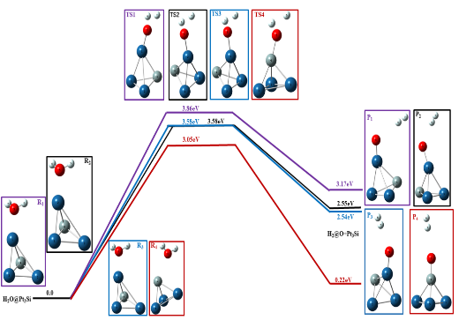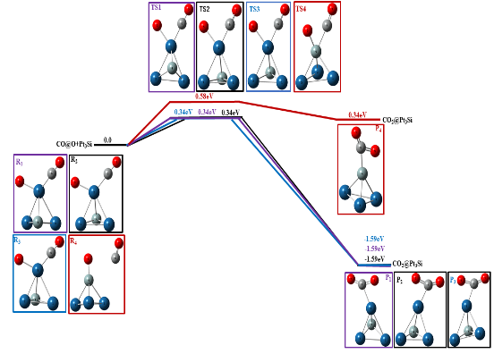

(a)

(b)

a b

Fig.1: The reaction paths of H2 generation (a) and CO oxidation (b) on a Pt3Si cluster.

References:

[1] X. Li, X. Chen, and L. Han, *J. Mater. Res.* **31**, 2956-2963(2016).

[2] J. Q. Wen, and Z. Y. Wen, *J. Supercond. Nov. Magn.* **31**, 3649–3656 (2018).

[3] H. Koc, E. Deligöz, and A. M. Mamedov, *Philos. Mag.* **91**, 3093-3107(2011).

**Acknowledgements：**This research was partially supported by NSFC (Nos. 91536105 and 11174186), the Natural Science Foundation of Xinjiang Autonomous Region (No.2015211A007), Tianshan Youth Pro gram (No.022018122), and the Tianshan Scholar Program.

***P-29***

**A bonding model for noble gas hydrides and noble gas-noble metal halides**

Yue Su, Lei Fu, Junjie Song, Gong Zhang, Kongshuang Tang, and Guiqiu Zhang*

*1College of Chemistry, Chemical Engineering and Materials Science, Collaborative Innovation Center of Functionalized Probes for Chemical Imaging, Key Laboratory of Molecular and Nano Probes, Ministry of Education, Shandong Normal University, Wenhua East Road 88, Jinan, Shandong 250014, P. R. China.*

The noble gas chemistry has been undergoing a renaissance[1-2] during the past 20 years. Many NgMX, HNgX, and the HNgX…H2O (M=Cu, Ag, Au; X=F, Cl, Br, I; Ng=Ne, Ar, Kr, Xe) complexes have been prepared in matrices or molecular beams, and characterized by vibrational and rotational spectroscopy. Yet, the bonding for HHgX and NgMX molecules is still not understood. This study has investigated the bonding of these two types of molecules by using the natural bond orbital and natural resonance theory (NBO/NRT) methods. The NBO/NRT results show that each of the studied Ng-MX molecules could be described as hybrid of two resonance structures Ng: M-X  Ng+-M :X-. Such a result meets the recent definition on ω-bonding proposed by Weinhold *et. al.*[3]. For the HNgX molecule, the ω-bonding picture in Fig.1 is essentially preserved[4-5]. Further calculated analyses on the H-Xe blue shift in HXeX…H2O complexes, unexpected add strong evidence to support the duality of dative and electron-shared bonding. The conclusion is that the bonding in both HNgX and NgMX molecules is ω-bonding, and that its covalent character is duality of dative and electron-shared bonding. Overall, the present work provides electronic and chemical insights that helps understanding the bonding in these two types of molecules and develop ω-bonding model.

**Dative or/and electron-shared bonding for the H-Ng bond?**

**H-: +Ng-X  H-Ng+ :X-**

Fig. 1 ω-bonding picture of HNgX molecules (Ng=Ne, Ar, Kr, Xe; X= F, Cl, Br, I).

References:

[1] L. Khriachtchev, M. Pettersson, N. Runeberg, J. Lundell and M. Räsänen, *Nature.* **406,** 874 (2000).

[2] L. Khriachtchev, M. Räsänen and R. B. Gerber, *Acc. Chem. Res.* **42,** 183 (2009).

[3] F. Weinhold, C. R. Landis and E. D. Glendening, *Int. Rev. Phys. Chem.*  **35,** 399 (2016).

[4] G. Zhang, H. Li, F. Weinhold and D. Chen, *Phys. Chem. Chem. Phys.*  **18,** 8015 (2016).

[5] G. Zhang, L. Fu, H. Li, X. Fan and D. Chen, *J. Phys. Chem. A* **121,** 5183 (2017).

***P-30***

**Visible Emission Spectroscopy of Benzyl-type Radicals Generated from 4-Chloro-*m*-Xylene**

Sang Kuk Lee

*Department of Chemistry and Research Institute for Basic Sciences, Pusan National University, Busan 46241, Republic of Korea*

Transient species such as molecular ions and radicals are believed to play an important role as intermediates in chemical reactions. Thus, the molecular and electronic structures could provide understanding to the characteristics of the chemical reactivity in reaction dynamics.

Ring-substituted benzyl radicals always exhibit electronic energies of the D1→D0 transition being shifted to red region with respect to the parental benzyl radical at 22002 cm-1. The red-shift of the electronic transition strongly depends on the number, type, and position of substituents.1,2 In this work, the red-shift of benzyl-type radicals was measured from the visible emission spectrum observed from corona discharge of 4-chloro-*m*-xylene using a pinhole-type glass nozzle in a technique of corona excited supersonic expansion which has been well developed in this laboratory over the past 20 years. The two types of benzyl-type radicals, 2-chloro-5-methylbenzyl and 4-chloro-3-methylbenzyl radicals were generated by a simple methyl C-H bond dissociation at the different location of precursor. The observed vibronic bands at 20342 and 21564 cm-1 were, respectively, assigned to the origin bands of the 2-chloro-5-methylbenzyl and 4-chloro-3-methylbenzyl radicals as shown below, red-shifted by 1660 and 438 cm-1 from the benzyl radical.

The large difference in the red-shift with substitution position has been explained using the Hückel’s molecular orbital theory, in which the delocalized π electrons is rotating over the molecular plane. The rotational period of the electrons is affected by the size and shape of molecular plane, from which we have found that the hyperconjugation between benzene ring and substituents is broken off at the nodal points of zero amplitude of electronic wave function.



In this talk, the scheme of the visible vibronic emission spectroscopy of molecular radicals will be presented, together with the development of rotational motion of delocalized π electrons to explain the red-shifts of the electronic transition energies of planar benzyl-type radicals.

**References**

[1] Manho Lim, Sang Kuk Lee, *Chem. Phys. Lett.* **713**, 10 (2018).

[2] Manho Lim, Sang Kuk Lee, *Chem. Phys. Lett.* **712**, 139 (2018).

***P-31***

**CO2-broadening and shift coefficients of sulfur dioxide near 4 µm**

Yurii G. Borkov1, Oleg M. Lyulin1, Tatyana M. Petrova1, Alexander M. Solodov1, Alexander A. Solodov1, Vladimir M. Deichuli1,2, Valerii I. Perevalov1

*1V. E. Zuev Institute of Atmospheric Optics, Siberian Branch, Russian Academy of Sciences, 1, Akademician Zuev square, 634055, Tomsk, Russia*

*2Tomsk State University, 36, Lenin Avenue, 634050, Tomsk, Russia*

The absorption spectra of the mixture of SO2 and CO2 at different partial pressures of both gases have been recorded at room temperature in the 4 μm region using the Bruker IFS 125 HR FTIR spectrometer. The multispectrum fitting procedure has been applied to these spectra to recover the CO2-broadening and shift parameters of the sulfur dioxide spectral lines. The CO2 broadening and the pressure induced shift coefficients for 1422 and 116 lines of the  *A*-type band of 32S16O2 and 34S16O2, respectively, have been derived. Beside, these coefficients have been derived for 254 lines of the  hot band of 32S16O2.The rotational dependence of the values of these coefficients is discussed. The CO2 pressure induced shift coefficients for this molecule are published for the first time. The comparison of the obtained broadening coefficients to those published by other authors for one pure rotational line and for the lines of the  *B*-type band is given.

***P-32***

**Comb-assisted Pound-Drever-Hall locked cavity ring-down spectrometer**

Ruimin Guo*, Ke Cao, Hewei Dong, Wenchao Cui

Email: guorm@nim.ac.cn

1. **Schematic diagram for the optical part**

The 1-meter-long cavity is actively stabilized to a HeNe laser. The light from an ECDL is divided into two beams. The p-polarized beam serves as the probe light, which is switched on-off by an acoustic-optic modulator (AOM) to measure the ring-down signal. The s-polarized is phase-modulated by an electro-optic modulator (EOM) to produce the sidebands needed for the PDH technique. The ECDL is kept to be tightly locked to the high finesse (about 190000) cavity during the ring-down signal measurement. An optical frequency comb is used to automatically measure the probe frequency for all the frequency points., which provide a highly precise frequency axis for the measured molecular spectra.

1. **Stable temperature in the measurement**

The cavity is put into a box and the temperature inside is controlled by a PID controller combining with heaters distributed on the inner wall of the box. Four thermistors are put along the cavity to measure the temperature. We did 7 measurements with different gas pressure and the experiment lasted about 26-27 minutes for one measurement. the standard deviation for the averaged temperature is less than 0.5 mK. The temperature gradient is less than 70 mK.

1. **Cavity length variation measured by frequency comb**

The cavity is locked to the HeNe laser and the ECDL is PDH-locked to the cavity. The cavity length variation can be evaluated by measuring the beat frequency between frequency comb and ECDL. The frequency variation of ECDL is less than 1 MHz in three hours, which corresponds to a cavity length variation of less than 2.1 nm.

1. **The minimum detectable absorption coefficient and NEA**

The minimum detectable absorption coefficient and the noise-equivalent absorption coefficient are about 7.6*10-12cm-1 and 5.3*10-12cm-1Hz-1/2, respectively

1. **Lingshape measurement and fitting of the CO2 transition P32e (30012)<-(00001)**

The tight PDH lock enables us to measure the molecular absorption spectra in a relative wide range (2 Torr to 38 Torr). Then the parameters such as collisional shift coefficient can be derived more precisely by fitting the experimental data using the multi-spectrum fitting method. From the above figures, it can be seen that the residuals for VP is relatively large, especially at high pressure. SDVP is worse than GP, NGP, SDGP and SDNGP. We can get line position, line intensity, shift coefficient, collisional width coefficient using our spectrometer now.

1. **Biref summary for our spectrometer**
2. Fast measurement speed. It takes about 26-27 mins to measure 7 GHz frequency range with a frequency interval of about 37.5MHz (120 ring-down events for one frequency point).
3. Stable cavity temperature.
4. Precise and fast frequency measurement. It only takes several seconds to measure the frequency for the comb.
5. Relative wide pressure range.

***P-33***

**QCL-based Ammonia Slip Sensor in Thermal Power Plant DeNOx Process**

Peng Kang, Ting-Jung Lin, Yin Wang

*Healthyphoton, Co., Ltd.*

Quantum cascade lasers (QCL) based mid/far-infrared spectroscopy is an indispensable technique for next-generation high sensitivity, high selectivity, real-time industrial gas monitoring applications. We report on a compact QCL spectrometer that can simultaneously measure ammonia and nitric oxide for flue gas denitrification (DeNOx) process optimization in thermal power plants. The QCL spectrometer has a response time less than 30 seconds, accuracy is better than 1%, and resolution of 0.1 ppmv/s and 0.4 ppmv/s for ammonia and nitric oxide respectively. The spectrometer performance and comparison results between QCL spectrometers and the conventional near-infrared laser based ammonia sensor will be presented.









Program March 6th-9th

|  |  |
| --- | --- |
| March 6th, Wed. |  |
| 14:00-18:00 Reception at USTC Reception Center Experts Building | |
| 17:30 Dinner buffet at USTC Reception Center Experts Building 2nd floor | |

|  |  |  |
| --- | --- | --- |
| March 7th, Thu. | | |
| 8:00 – 8:30 Registration at Venue (5th floor of East Campus Activity Center) | | |
| 8:30 – 8:45 Welcome | | |
| Session A Chair: Bor-Chen Chang | | |
| 8:45 – 9:15  (A1) | **PL Luo**  High-resolution mid-infrared laser spectroscopy of small Criegee intermediates | |
| 9:15 – 9:33  (A2) | **DF Zhao**  High resolution laser spectroscopy of astrophysically relevant small molecules | |
| 9:33 – 9:51  (A3) | **LH Deng**  Measurement of OH Radicals Based on Concentration Modulation Absorption Spectroscopy | |
| 9:51 – 10:09  *(A4) | **YH Tsao**  HCl Formation in the Reaction of Cl Atom with trans-2-Butene Probed with Step-scan Time-resolved Fourier-transform IR Emission Spectroscopy | |
| 10:09-11:08 | **Photography, Coffee break and posters** | |
| Session B Chair: Thomas Schultz | | |
| 11:08 – 11:26  (B1) | **M Baba**  High-resolution spectroscopy of 9-methylanthracene | |
| 11:26 – 11:44  (B2) | **G Feng**  Rotational and theoretical characterization of sulfur centered non-covalent interactions | |
| 11:44 – 12:02  (B3) | **Y Jin**  The preferred conformers of the tetrafluoro-1,3-dithietane- isopropylamine complex by rotational spectroscopy | |
| 12:02 – 12:20  (B4) | **LS Ma**  Study on the Stark effect to conversion of nuclear spin isomers of CH3OH | |
| 12:30 – 14:00 Lunch buffet ( 3rd floor of East Campus Activity Center) | | |
| Session C Chair: Kaito Takahashi | | |
| 14:00 – 14:30  (C1) | **A Nishiyama**  Highly Sensitive and Broadband Frequency Comb Spectroscopy Using a High Finesse Cavity | |
| 14:30 – 14:48  (C2) | **RM Guo**  Comb-assisted Pound-Dreve-Hall-locked cavity ring-down spectrometer | |
| 14:48 – 15:06  (C3) | **M Misono**  Frequency control of a single mode Ti:Sapphire laser  with reference to an optical frequency comb | |
| 15:06 – 15:24  *(C4) | **TP Hua**  Cavity-enhanced saturation spectroscopy of molecules with sub-kHz accuracy | |
| 15:24 – 15:42  (C5) | **ZQ Chen**  High-resolution Gigahertz and Terahertz Spectroscopy of the isotopically chiral molecule trans-2,3-dideutero-oxirane (c-CHD-CHDO) | |
| 15:42 – 16:30 | **Coffee break and posters** | |
| Session D Chair: Ling Jiang | | |
| 14:00 – 14:30  (D1) | | **Q Gou**  Rotational Pursuits on Internal Dynamics of Water in Molecular Complexes |
| 14:30 – 14:48  *(D2) | | **N Stolarczyk**  *Ab initio* quantum scattering calculations of beyond-Voigt line-shape parameters for the H2-He system for the HITRAN database |
| 14:48 – 15:06  *(D3) | | **Z Liu**  Mid-infrared quantum cascade laser spectroscopy of the Ar-NO complex: fine and hyperfine structure |
| 15:06 – 15:24  (D4) | | **J.U Grabow**  Dual Excitation-Emission Propagation (DEEP) vs. Coaxial Orientation Beam-Resonator Arragenment (COBRA) FTMW Spectrometers: Rotational Studies of (chiral) Molecules/Complexes in Jets (& Flames) |
| 18:00 Dinner buffet at USTC Reception Center Experts Building 2nd floor | | |

|  |  |
| --- | --- |
| March 8th, Fri. | |
| Session E Chair: Malgorzata Biczysko | |
| 8:30 – 9:00  (E1) | **CJ Moon**  IR induced isomerization of invisible isomers (I5) spectroscopy: watching the invisible conformers of *ortho*-substituted phenols |
| 9:00 – 9:18  *(E2) | **HR Tsai**  Infrared Spectra of BrC6H6 in Solid *p-*H2 |
| 9:18 – 9:36  *(E3) | **Z. Wu**  Spectroscopic Detection of Interstellar Sulfur Oxides |
| 9:36 – 9:54  (E4) | **BC Chang**  Spectroscopic Studies of Luminescent Crystals Containing Trivalent Lanthanides |
| 9:54 – 10:12  *(E5) | **Y Zhai**  Quantum Vibration Perturbation Theory: A Way of Systematically Improving the Accuracy in Simulating Infrared Probe Spectra |
| 10:12 – 11:08 | **Coffee break** |
| Session F Chair: Chuan-Xi Duan | |
| 11:08 – 11:26  (F1) | **L Jiang**  Vacuum Ultraviolet Free Electron Laser-Based Infrared Spectroscopy of Neutral Water Clusters |
| 11:26 – 11:44  *(F2) | **Y Zheng**  Rotational spectroscopy of the n-propylamine-water complex |
| 11:44 – 12:02  *(F3) | **Q Yang**  Theoretical Investigations of the Optical Properties of Helicene-Iridium Complexes |
| 12: 02 – 12:20  (F4) | **M Biczysko**  Molecular systems under external stimuli |
| 12:30 – 14:00 Lunch buffet ( 3rd floor of East Campus Activity Center) | |

|  |  |  |
| --- | --- | --- |
| Session G Chair: Masatoshi Misono | | |
| 14:00 – 14:30  (G1) | **CF Cheng**  Dissociation energy of molecular hydrogen at 10-9 accuracy | |
| 14:30 – 14:48  (G2) | | **A.S.-C Cheung**  Electronic transitions of ScO in the UV region |
| 14:48 – 15:06  *(G3) | | **CW Chen**  A new 4Σ - a4Πi Electronic Transition of ScC in the near infra-red |
| 15:06 – 15:24  (G4) | | **D Witsch**  Infrared Spectroscopy of TiO in a supersonic jet expansion |
| 15:24 – 15:42  (G5) | | **V Perevalov**  Line intensities of the radioactive isotopologues of the carbon monoxide molecule |
| 15:42 – 16:30 | | **Coffee break** |
| 16:30 | | **Memorial Session, Chair: Jens-Uwe Grabow** |
| 18:30 – 20:00 Conference Banquet at Gaosu New Century International Hotel Anhui | | |

|  |  |
| --- | --- |
| March 9th, Sat. | |
|  | |
| Section H Chair: Qian Gou | |
| 8:30 – 8:48  *(H1) | **ZD Sun**  Conversion dynamics of nuclear spin isomers of the CH3OH molecule in the gas phase |
| 8:48 – 9:06  (H2) | **M. Xie**  Spectral Characterization of Three-Electron Two-Center (3e-2c) Bonds of Gaseous CH3SH Clusters |
| 9:06 – 9:24  *(H3) | **XL Li**  Sulfur hydrogen bonding: diethyl disulfide-H2O dimer in gas phase studied by microwave spectroscopy |
| 9: 24 – 9:42  *(H4) | **JT Yang**  QVP Theory: Application to the Sum Frequency Generation |
| 9:42 – 10:00  *(H5) | **W Fan**  Amyloid Fibrillation of Hen Egg White Lysozyme Acceerated by Succinimide |
| 10:00 – 10:30 | **Coffee break** |
| Section I Chair: D.-F. Zhao | |
| 10:30 – 10:48  (I1) | **K Takahashi**  Is the OH Stretching Vibrational Transition Moment of Simple Molecules Aligned Along the OH Bond? |
| 10:48 – 11:06  (I2) | **C. Fittschen**  Near-IR spectroscopy of Radicals using cw-CRDS coupled to Laser photolysis |
| 10:06 – 11:24  (I3) | **CL Li**  A proposal for laser directly cooling AgH & AgD radicals |
| 11:24 – 11:42  (I4) | **YC Hsu**  The electronic excited state of C3Ar studied by hole burning spectroscopy and the ab initio calculation |
| 11:42 – 12:10 Award and Closing | |
| 12:20 – 13:50 Lunch buffet ( 3rd floor of East Campus Activity Center) | |
| 14:00- Lab Tour/City Tour | |

All lectures are at 5th floor of East Campus Activity Center (东区活动中心五楼)

Lunches at 3rd floor of East Campus Activity Center (东区活动中心三楼)

Dinners at 2nd floor of Reception Center Experts Building (专家楼二楼)

Banquet at 1st floor Gaosu New Century International Hotel (高速开元酒店一楼自助餐厅)

3rd Asian Workshop on Molecular Spectroscopy (Mar 6-9, 2019)

|  |  |  |  |  |  |  |
| --- | --- | --- | --- | --- | --- | --- |
| Mar 6 | Mar 7 | | Mar 8 | | Mar 9 | |
| 14:00  Reception **@** Reception Center Experts Building | 08:30 Opening | 14:00 **C1** A Nishiyama | 08:30 **E1** CJ Moon | 14:00 **G1** CF Cheng | 08:30 **H1** ZD Sun | 14:30  Lab Tour/City Tour |
| 08:45 **A1** PL Luo | 14:30 **C2** RM Guo | 09:00 **E2** HR Tsai | 14:30 **G2** A. Cheung | 08:48 **H2** M. Xie |
| 09:15 **A2** DF Zhao | 14:48 **C3** M Misono | 09:18 **E3** Z. Wu | 14:48 **G3** CW Chen | 09:06 **H3** XL Li |
| 09:33 **A3** LH Deng | 15:06 **C4** TP Hua | 09:36 **E4** BC Chang | 15:06 **G4** D Witsch | 09:24 **H4** JT Yang |
| 09:51 **A4** YH Tsao | 15:24 **C5** ZQ Chen | 09:54 **E5** Y Zhai | 15:24 **G5** V Perevalov | 09:42 **H5** W Fan |
| 10:09 Coffee, Poster | 15:42 Coffee, Poster | 10:12 Coffee, Poster | 15:42 Coffee Poster | 10:00 Coffee |
| 11:08 **B1** M Baba | 16:48 **D1** Q Gou | 11:08 **F1** L Jiang | 16:30 **Memorial S.** | 10:30 **I1** K Takahashi |
| 11:26 **B2** G Feng | 17:06 **D2** N Stolarczyk | 11:26 **F2** Y Zheng | 10:48 **I2** C. Fittschen |
| 11:44 **B3** Y Jin | 17:24 **D3** Z Liu | 11:44 **F3** Q Yang | 11:06 **I3** CL Li |
| 12:02 **B4** LS Ma | 17:42 **D4** JU Grabow | 12:02 **F4** M Biczysko | 11:24 **I4** YC Hsu |
|  |  |  | 11:42 **Award/Closing** |
| 17:30 Dinner **#** | 12:30 Lunch * | 18:00 Dinner **#** | 12:30 Lunch * | 18:30 Banquet **$** | 12:20 Lunch * |

All lectures are at 5th floor of East Campus Activity Center (东区活动中心五楼)

* Lunches at 3rd floor of East Campus Activity Center (东区活动中心三楼)

# Dinners at 2nd floor of Reception Center Experts Building (专家楼二楼)

$ Banquet at 1st floor Gaosu New Century International Hotel (高速开元酒店一楼自助餐厅)